
Activity Guide
‘Non-household Customers’

Yorkshire Water Business Plan
Acceptability and Affordability
Markets:
UK


Human8 Team:
Paige Blake
PaigeB@wearehuman8.com
Sarah Fixter
SarahF@wearehuman8.com

Client Stakeholders:
Donna Hildreth
Naveed Majid
Jenna Spence

Date:
18 August 2023

PROJECT DETAILS
Fill in information below.
Research Approach
Data Collection Source(s): | Your Water Community + Panel
Questionnaire Length: | 15 - 20 minutes
Project Type: | Insight Generation
Questionnaire Design: | Cross sectional design
Markets, Languages & Translations
Markets & Languages per market: | UK only
Sample Spec
Total Sample | 300 businesses
SAMPLE GROUPS | Business Panel = max. quota 300
Sample Screening (estimated incidence rate if known…%)
Visual / Auditory Limitation allowed: | Yes
Sample Quota(s)
PANEL ONLY
Max quota n=300
X`Stimuli Overview (internal use only: stimuli requirements can be found here)
Video
One page summary
Performance commitments

Mobile
The survey is drafted to be as: | Mobile compatible

PROJECT OBJECTIVES AND BACKGROUND INFORMATION

Background Business Objective (i.e., why is the research being done, what decisions are being made on the back of it, what’s led to research being part of the solution & what’s the business need for the research?)
Yorkshire Water want to test the entirety of their business plan with customers to determine its acceptability and affordability across different customer groups. This includes all the investment they plan to make in the next 5 year business planning period as well as the impact it will have on customer’s bills.

Research Objectives (i.e., what’s the research addressing, what behaviour is it hoping to understand in people, what decisions are being made on the back of the results that could not otherwise be made?)
- How supportive are customers of our business plan overall?
- What are customers thoughts on our vision and outcomes?
- What do customers think of what our plan will achieve (the big performance improvement areas)
  - How supportive are customers of these big performance improvement areas? Anything missing/not going far enough?
- How supportive are customers of each individual Performance Commitment (PC) target?
- How important are each of the PC targets to our customers?
- Do they think we should be doing more in any areas? Which ones?
  - What targets do should be aiming for?
  - When should we aim to achieve them?
- Is the bill affordable to customers? Why? / Why not? What would make it more acceptable to customers – e.g. more financial support for those struggling to afford their bill?
Is the plan acceptable? Why? / Why not?

Key Project Timings
Project Stage | Timings | Responsible
Activity Guide Signed Off | 21/08/23 | Client
Scripting | 22/08/23 | Human8
Live | 24/08/23 | Human8
Toplines shared | 08/09/23 | Human8
Report shared | 15/09/23 | Human8
QUESTIONNAIRE
NB. Supporting text on all questions in the grey boxes is for internal use.

SECTION 1: PROFILING

Info Text: Thanks for joining us. Today we’d like to talk to you about Yorkshire Water’s Business Plan commitments.

Before we get started, we just need to ask you a few questions about you and your employer…
Page break: Yes
Title: Info1
Question type: Info
Implementation QID: Info1
Filter / routing information: No
Other potential instructions: No

- Question text: Firstly, please could you let us know, is your business run from business premises or from somewhere else, e.g. a home residence or a mobile business?
Instruction text: Select all that apply
Page break: Yes
Title: Q1
Question type: Single Select
Randomisation: None
Implementation QID: Q1
Filter / routing information: No
Other potential instructions: No

Answer options | Precodes | Fix | Excl. | Open | Screen
Business premises | 1 | ☐ | ☐ | ☐ | ☐
No fixed business premises (e.g. van / home residence) | 2 | ☐ | ☐ | ☐ | ☐
Don’t know | 3 | ☐ | ☐ | ☐ | ☒

Info Text: We’re only looking to speak organisations with business premises today, so we won’t take up any more of your time.
Page break: Yes
Title: ClosingThanksPremises
Question type: Info
Implementation QID: ClosingThanksPremises
Filter / routing information: if Q1 does not = precode 1
Other potential instructions: No

- Question text: Does your company currently have a premises in the Yorkshire Water Region?
Instruction text: Select all that apply
Page break: Yes
Title: Q2
Question type: Single Select
Randomisation: None
Implementation QID: Q2
Filter / routing information: No
Other potential instructions: No

Answer options | Precodes | Fix | Excl. | Open | Screen
Yes | 1 | ☐ | ☐ | ☐ | ☐
No | 2 | ☐ | ☐ | ☐ | ☒
Don’t know | 3 | ☐ | ☐ | ☐ | ☒

Info Text: We’re only looking to speak organisations based in Yorkshire today, so we won’t take up any more of your time.
Page break: Yes
Title: ClosingThanksRegion
Question type: Info
Implementation QID: ClosingThanksRegion
Filter / routing information: if Q2 does not = precode 1
Other potential instructions: No

- Question text: Which parts of the Yorkshire Water region does your company have premises in?
Instruction text: Select all that apply
Page break: Yes
Title: Q3
Question type: Multi Select
Randomisation: None
Implementation QID: Q3
Filter / routing information: No
Other potential instructions: No

Answer options | Precodes | Fix | Excl. | Open | Screen
North Yorkshire | 1 | ☐ | ☐ | ☐ | ☐
West Yorkshire | 2 | ☐ | ☐ | ☐ | ☐
South Yorkshire | 3 | ☐ | ☐ | ☐ | ☐
East Riding | 4 | ☐ | ☐ | ☐ | ☐
I’m not sure | 6 | ☐ | ☐ | ☐ | ☐

- Question text: Are you solely or jointly responsible as the decision maker for your organisation’s water and sewerage service at any of its premises in Yorkshire?
Instruction text: Please select one
Page break: Yes
Title: Q4
Question type: Single Select
Randomisation: None
Implementation QID: Q4
Filter / routing information: No
Other potential instructions: Screen out those not involved in water bill

Answer options | Precodes | Fix | Open | Screen
Yes, I am | 1 | ☐ | ☐ | ☐
No, I am not | 2 | ☐ | ☐ | ☒
Unsure | 3 | ☐ | ☐ | ☒

Info Text: We’re only looking to speak to those who handle the company’s water bill, so we won’t take up any more of your time today.
Page break: Yes
Title: ClosingThanksBillPay
Question type: Info
Implementation QID: ClosingThanksBillPay
Filter / routing information: IF Q4=CODE 2 OR 3 (NOT BILL HANDLER)
Other potential instructions: No

- Question text: Approximately how many employees does your organisation have working in the Yorkshire region?
Instruction text: Please select one.
Page break: Yes
Title: Q5
Question type: Single Select
Randomisation: None
Implementation QID: Q5
Filter / routing information: No
Other potential instructions:

Answer options | Precodes | Fix | Open | Screen
1-9 employee | 1 | ☐ | ☐ | ☐
10-49 employees | 2 | ☐ | ☐ | ☐
50-99 employees | 3 | ☐ | ☐ | ☐
100-249 employees | 4 | ☐ | ☐ | ☐
250+ employees | 5 | ☐ | ☐ | ☐
Don’t know | 6 | ☐ | ☐ | ☒

- Question text: And what is the main industry of your business working in the Yorkshire region?
Instruction text: Please select one.
Page break: Yes
Title: Q6
Question type: Single Select
Randomisation: None
Implementation QID: Q6
Filter / routing information: No
Other potential instructions: Screen out people working in the water industry (Q4=5)

Answer options | Precodes | Fix | Open | Screen
Agriculture, Forestry and Fishing | 1 | ☐ | ☐ | ☐
Mining and Quarrying | 2 | ☐ | ☐ | ☐
Manufacturing | 3 | ☐ | ☐ | ☐
Electricity, gas, steam and air conditioning supply | 4 | ☐ | ☐ | ☐
Water supply, sewerage, waste management and remediation activities | 5 | ☐ | ☐ | ☒
Construction | 6 | ☐ | ☐ | ☐
Wholesale and retail trade; repair of motor vehicles and motorcycles | 7 | ☐ | ☐ | ☐
Transportation and storage | 8 | ☐ | ☐ | ☐
Accommodation and food service activities | 9 | ☐ | ☐ | ☐
Information and communication | 10 | ☐ | ☐ | ☐
Financial and insurance activities | 11 | ☐ | ☐ | ☐
Real estate activities | 12 | ☐ | ☐ | ☐
Professional, scientific and technical activities | 13 | ☐ | ☐ | ☐
Administrative and support service activities | 14 | ☐ | ☐ | ☐
Public administration and defence; compulsory social security | 15 | ☐ | ☐ | ☐
Education | 16 | ☐ | ☐ | ☐
Human health and social work activities | 17 | ☐ | ☐ | ☐
Arts, entertainment and recreation | 18 | ☐ | ☐ | ☐
Other service activities (Please Specify) | 19 | ☐ | ☐ | ☐

Info Text: We’re only looking to speak to who work in certain industry sectors today, so we won’t take up any more of your time today.
Page break: Yes
Title: ClosingThanksBillPay
Question type: Info
Implementation QID: ClosingThanksBillPay
Filter / routing information: IF Q6=CODE 5 (work in water industry)
Other potential instructions: No

- Question text: Which of the following best describes your role within the organisation?
Instruction text: Select one
Page break: Yes
Title: Q7
Question type: Single Select
Randomisation: Randomised Rows
Implementation QID: Q7
Filter / routing information: No
Other potential instructions: No

Answer options | Precodes | Fix | Open | Screen
Business owner | 1 | ☐ | ☐ | ☐
Senior management | 2 | ☐ | ☐ | ☐
Middle management | 3 | ☐ | ☐ | ☐
Lower management | 4 | ☐ | ☐ | ☐
Other | 5 | ☐ | ☐ | ☐

Info Text: Thanks for taking part in this survey. Unfortunately, we’re looking for people aged 18 or above, so we won’t take up anymore of your time today. Please click the ‘Finish Survey’ button to finish up.
Page break: Yes
Title: ClosingThanksAge
Question type: Info
Implementation QID: ClosingThanksAge
Filter / routing information: IF Q8 = CODE 1 (UNDER 18)
Other potential instructions:

- Question text: Which of the following do you identify as…?
Instruction text: Please select one
Page break: Yes
Title: Q8
Question type: Single Select
Randomisation: None
Implementation QID: Q8
Filter / routing information: Ask all
Other potential instructions: No

Answer options | Precodes | Fix | Open | Screen
Female | 1 | ☐ | ☐ | ☐
Male | 2 | ☐ | ☐ | ☐
I identify in another way | 3 | ☐ | ☐ | ☐
Prefer not to say | 4 | ☐ | ☐ | ☐

- Question text: Taking everything into account, how satisfied are you with Yorkshire Water as a supplier to your business? Please use a scale of 0 to 10 where 10 is equal to extremely satisfied and 0 is equal to extremely dissatisfied.
Instruction text: Please select one option
Page break: Yes
Title: Q9
Question type: Single Select
Randomisation: Randomised Rows
Implementation QID: ID here
Filter / routing information: No
Other potential instructions: No

Answer options | Precodes | Fix | Open | Screen
0 – extremely dissatisfied | 1 | ☐ | ☐ | ☐
1 | 2 | ☐ | ☐ | ☐
2 | 3 | ☐ | ☐ | ☐
3 | 4 | ☐ | ☐ | ☐
4 | 5 | ☐ | ☐ | ☐
5 | 6 | ☐ | ☐ | ☐
6 | 7 | ☐ | ☐ | ☐
7 | 8 | ☐ | ☐ | ☐
8 | 9 | ☐ | ☐ | ☐
9 | 10 | ☐ | ☐ | ☐
10 – extremely satisfied | 11 | ☐ | ☐ | ☐

- Question text: How satisfied or dissatisfied are you with the value for money of the services your business receives from Yorkshire Water? Please use a scale of 0 to 10 where 10 is equal to extremely satisfied and 0 is equal to extremely dissatisfied.
Instruction text: Select one
Page break: Yes
Title: Q10
Question type: Single Select
Randomisation: Randomised Rows
Implementation QID: ID here
Filter / routing information: No
Other potential instructions: No

Answer options | Precodes | Fix | Open | Screen
0 – extremely dissatisfied | 1 | ☐ | ☐ | ☐
1 | 2 | ☐ | ☐ | ☐
2 | 3 | ☐ | ☐ | ☐
3 | 4 | ☐ | ☐ | ☐
4 | 5 | ☐ | ☐ | ☐
5 | 6 | ☐ | ☐ | ☐
6 | 7 | ☐ | ☐ | ☐
7 | 8 | ☐ | ☐ | ☐
8 | 9 | ☐ | ☐ | ☐
9 | 10 | ☐ | ☐ | ☐
10 – extremely satisfied | 11 | ☐ | ☐ | ☐

SECTION 2: CONTEXT TO THE PLAN

Info Text: Thanks for your input so far.

As part of running their business, Yorkshire Water creates a 5-year Business Plan. This outlines all the investment Yorkshire Water plan to make in the next 5 years as well as the impact this investment will have on customer’s bills.

To start with, we have a little bit of information for you about how the process for developing the business plan and the type of things that Yorkshire Water need to consider. Once you have had chance to reflect on this information and answer a few questions, we will show you a video outlining the business plan itself.

Page break: Yes
Title: Info2
Question type: Info
Implementation QID: Info2
Filter / routing information: No
Other potential instructions: No

- Question text:
The Price Review:
Every five years, water companies develop a ‘business plan’ that sets out their ambition for the services they provide, including the proposed cost to customers, Yorkshire Water is currently working on their 2025-2030 plan. Final plans and prices are finalised by Ofwat. Yorkshire Water must show Ofwat that our plan reflects what customers want.
How we engaged:
Yorkshire Water have had 45,000 quality conversations/consultations with customers over the past three years. This involved focus groups, surveys, door to door surveys and even sitting down with some of our most vulnerable customers in their homes.

Based on the information above, how do you feel about Yorkshire Water and the process they have been through to develop their plan?
Page break: Yes
Title: Q11
Question type: Five point sliding scale
Randomisation: None
Implementation QID: Q11
Filter / routing information: No
Other potential instructions: No

Answer options | Precodes | Fix | Open
Very positive | 1 | ☐ | ☐
- | 2 | ☐ | ☐
- | 3 | ☐ | ☐
- | 4 | ☐ | ☐
Very negative | 5 | ☐ | ☐

- Question text: Please could you briefly share the main reasons for that rating below?
Instruction text: There are no right or wrong answers – please be as honest as possible!
Page break: Yes
Title: Q12
Question type: Essay
Implementation QID: Q12
Filter / routing information: No
Other potential instructions: No

- Question text:
Our performance:
While our performance has continued to improve, we understand that in some areas it isn’t where it needs to be. In 2021/22 we met 25 of our 44 performance commitments, failing in important commitments such as internal sewer flooding, pollution and the length of time customers are without water due to an unplanned disruption. The last few years have proven to be much tougher than we expected. We were slowed down by the pandemic and the challenges of increasingly volatile weather patterns, including Storm Arwen, the highest temperatures and worst drought in 15 years in 2022. However, we did excel in other priority areas including achieving our leakage targets, external sewer flooding and mains repairs.
Storm overflows:
We know water companies have featured in the media a lot recently, often in relation to the use of storm overflow spills into rivers. Storm overflows are designed to stop our customers’ properties and outdoor spaces from being flooded with sewage when heavy rain fills the system. However, population growth and changing weather patterns mean these are being used more often, and we know this is no longer acceptable.
To address this, Yorkshire Water shareholders have committed £100m to reduce spills to the environment from storm overflows. This is on top of investment Yorkshire Water has already committed to storm overflows by 2025.
Just so you know, when we fail to deliver the service we promised, a penalty is triggered in the form of a refund to customers. For internal sewer flooding alone, a penalty of £9.5 million was triggered - customers received a refund of £3.31 in their annual bill for 2022/23.

Based on the information above, how do you feel about Yorkshire Water and the process they have been through to develop their plan?
Page break: Yes
Title: Q13
Question type: Five point sliding scale
Randomisation: None
Implementation QID: Q13
Filter / routing information: No
Other potential instructions: No

Answer options | Precodes | Fix | Open
Very positive | 1 | ☐ | ☐
- | 2 | ☐ | ☐
- | 3 | ☐ | ☐
- | 4 | ☐ | ☐
Very negative | 5 | ☐ | ☐

- Question text: Please could you briefly share the main reasons for that rating below?
Instruction text: There are no right or wrong answers – please be as honest as possible!
Page break: No
Title: Q14
Question type: Essay
Implementation QID: Q14
Filter / routing information: No
Other potential instructions: No

- Question text:
And now, here is the final piece of information that we need you to read about how we have developed our plan.
Statutory Drivers of our plan:
This business plan cycle is very different to past cycles. This is because Yorkshire Water and every water and wastewater company, must deliver the largest ever environmental programme of work - this has been mandated by the government.
This focuses on the need to protect our environment for the long-term by not taking too much water from the environment and it means we will need to change how we manage our water and improve the quality of the water we put back into the environment. The extent of this vast, but we know this aligns with our customers priorities. Meeting this programme of work is going to cost £1.7 billion.
As well as this, from 2025-2030 Yorkshire Water and every other wastewater company must significantly reduce the use of storm overflows by law. This is especially expensive in the Yorkshire region due to our Victorian heritage; we have more overflows than many other wastewater companies. Meeting these obligations is going to cost £700 million from 2025-2030.
In addition to this, customers supported us bringing forward our programme of work to tackle the reduction of storm overflows used on the coast from 2030-2035 to 2025-2030. Addressing these additional coastal storm overflows will cost £300 million.

Why we can’t do it all:
Whilst we’d love to ensure we never fail, with the creation and delivery of 1.2bn litres of safe clean drinking water to over 5 million customers and businesses and the capturing of and treating of 1 billion litres of litres of wastewater every day, there is an endless to-do list and one that we work hard on every single day. Achieving zero failures is impossible with the technology available today and would be prohibitively expensive for our customers, this is why we continue to innovate and will always strive to make improvements year on year despite the challenges posed by climate change and population growth.

Based on the information above, how do you feel about Yorkshire Water and the process they have been through to develop their plan?
Page break: Yes
Title: Q15
Question type: Five point sliding scale
Randomisation: None
Implementation QID: Q15
Filter / routing information: No
Other potential instructions: No

Answer options | Precodes | Fix | Open
Very positive | 1 | ☐ | ☐
- | 2 | ☐ | ☐
- | 3 | ☐ | ☐
- | 4 | ☐ | ☐
Very negative | 5 | ☐ | ☐

- Question text: And again, please could you briefly share the main reasons for that rating here?
Instruction text: There are no right or wrong answers – please be as honest as possible!
Page break: Yes
Title: Q16
Question type: Essay
Implementation QID: Q16
Filter / routing information: No
Other potential instructions: No

SECTION 3: THE PLAN

Info Text: Thanks for your input so far.

Now we are going to show you a short video summary of the progressive elements proposed in the Yorkshire Water Business Plan for 2025-2030. Please watch this and then answer some questions on how you feel about the plan.

Click here to watch the video through, it will take 4 minutes and you will need your sound turned on.

Please note that the video does not outline every specific initiative/target that Yorkshire Water are aiming towards. You will view Yorkshire Water's full list of commitments shortly.

As a reminder, please think about Yorkshire Water as a provider to your business when you are viewing the plan and answering the questions that follow.
Title: Info3
Question type: Info
Implementation QID: Info3
Filter / routing information: No

<LINK TO BUSINESS PLAN VIDEO>

- Question text: Did you watch the whole video through and listen to the audio that accompanied it?
Page break: No
Title: Q17
Question type: Single Code
Randomisation: None
Implementation QID: Q17
Filter / routing information: No
Other potential instructions: No

Answer options | Precodes | Fix | Open
Yes | 1 | ☐ | ☐
No, I had problems playing it / hearing it | 2 | ☐ | ☐

- Question text:
Based on the video you have just seen, to what extent do you agree or disagree with the following statements about the Business Plan…?

If you were unable to watch the video you can click on the link below to view this information. Please read and consider this before answering the questions. You can also click here if you want to refresh your memory on the plan.

Insert link to video transcript here
Instruction text: Please click on the buttons to rate the statements
Page break: Yes
Title: Q18
Question type: Rating Scale
Randomisation: Randomised
Implementation QID: Q18
Filter / routing information: No
Other potential instructions: No

Answer options | Precodes | Fix | Open
I like the overall vision; “a thriving Yorkshire; right for customers and right for the environment” | 1 | ☐ | ☐
The plan reflects my priorities as a business customer | 2 | ☐ | ☐
The plan is clear | 3 | ☐ | ☐
The goals and outcomes cover the main areas I would expect | 4 | ☐ | ☐
The plan seems realistic and achievable | 5 | ☐ | ☐
The plan will benefit Yorkshire | 6 | ☐ | ☐
I trust Yorkshire Water to deliver this plan | 7 | ☐ | ☐
I support this plan and what it hopes to achieve

Scale options | Precodes | Fix
Strongly agree | 1 | ☐
Somewhat agree | 2 | ☐
Neither agree nor disagree/I don’t mind | 3 | ☐
Somewhat disagree | 4 | ☐
Strongly disagree | 5 | ☐

- Question text: Is there anything in particular that you like or dislike about the plan? If so, please could you tell us a little about this below.
Instruction text: There are no right or wrong answers – please be as honest as possible!
Page break: Yes
Title: Q19
Question type: Essay
Implementation QID: Q19
Filter / routing information: No
Other potential instructions: No

- Question text: Is there anything missing from the plan that you would expect it to include?

(Please note that the video does not outline every specific initiative/target that Yorkshire Water are aiming towards. You can view Yorkshire Water's full list of performance commitments <here> if you wish; you will also be shown these later in the survey)

Insert link to performance commitments

Instruction text: There are no right or wrong answers – please be as honest as possible!
Page break: Yes
Title: Q20
Question type: Essay
Implementation QID: Q20
Filter / routing information: No
Other potential instructions: No

SECTION 6: PERFORMANCE COMMITMENTS

Info Text: Thank you so much for all of your input so far. We just have one final section for you, on the specific performance commitments that we’re proposing for each of the 6 outcome areas.

While we’d love you to read it all in detail, the main thing to focus on is the measures and targets as this is what the next questions will be about.
Page break: Yes
Title: Info4
Question type: Info
Implementation QID: ID here
Filter / routing information: No
Other potential instructions: No

Hidden Question: HV Target Order
Page break: Yes
Title: HV Target Order
Question type: Hidden Variable
Randomisation: None
Implementation QID: HV Target Order
Filter / routing information: Respondents to see all sections. Randomise order shown sections.
Other potential instructions: No

Answer options | Precodes
Secure, safe clean water supplies (Q25, Q26 & Q27) | 1
First class customer service (Q28, Q29 & Q30) | 2
Bills everyone can afford (Q31 & Q32) | 3
Modern and sustainable infrastructure (Q33, Q34 & Q35) | 4
Net zero carbon emissions (Q36 & Q37) | 5
A healthy, natural environment (Q38, Q39 & Q40) | 6

- Question text: Here are the measures & performance commitments that Yorkshire Water are proposing relating to the outcome ‘Secure, safe clean water supplies’.
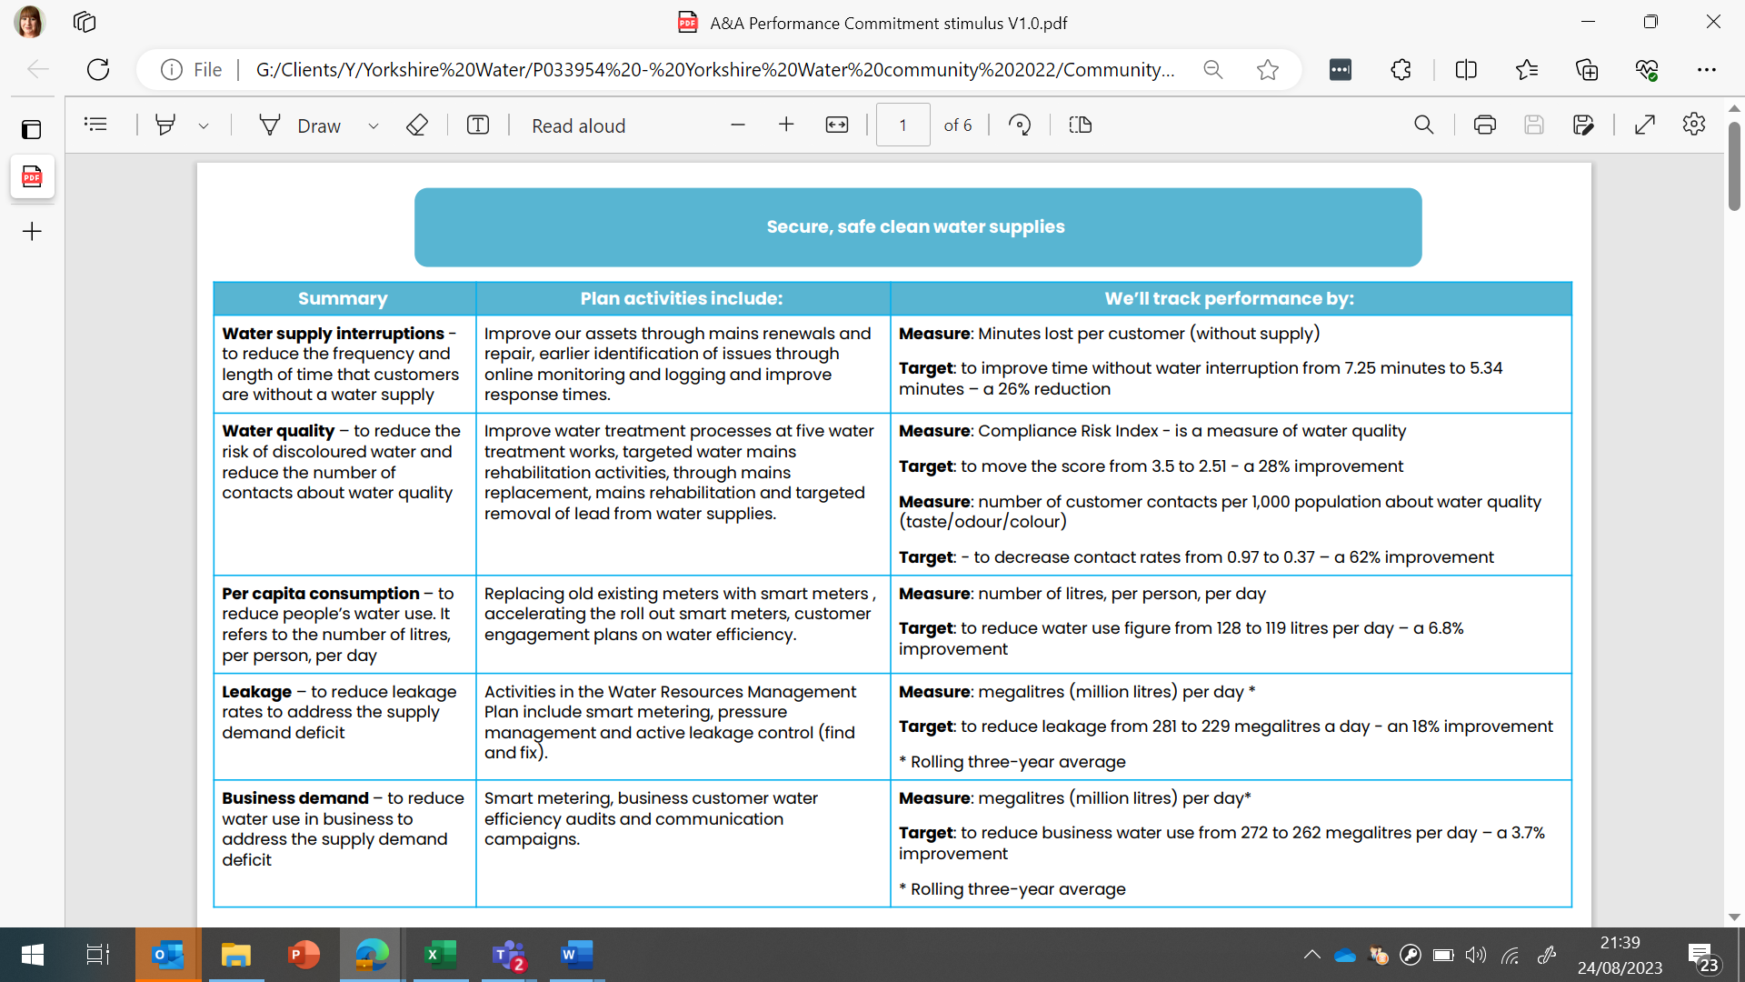
Click the image to enlarge or click here to open the image in a new window.
Based on what you have read, how supportive are you of the targets/performance commitments Yorkshire Water has set for this outcome overall?
Instruction text: Please select one
Page break: Yes
Title: Q21
Question type: Single Select
Randomisation: Randomised Rows
Implementation QID: Q21
Filter / routing information: No
Other potential instructions: No

Answer options | Precodes | Fix | Open | Screen
Very supportive | 1 | ☐ | ☐ | ☐
Fairly supportive | 2 | ☐ | ☐ | ☐
I don’t mind | 3 | ☐ | ☐ | ☐
Fairly unsupportive | 4 | ☐ | ☐ | ☐
Very unsupportive | 5 | ☐ | ☐ | ☐
I’m not sure | 6 | ☐ | ☐ | ☐

- Question text: Which of these targets in particular are you unsupportive of?
Click the image to enlarge or click here to open the image in a new window.

Instruction text: Please select all that apply
Page break: Yes
Title: Q22
Question type: Multi Select
Randomisation: None
Implementation QID: Q22
Filter / routing information: If Q21 = 4 or 5
Other potential instructions: No

Answer options | Precodes | Fix | Excl. | Open | Screen
Water supply interruptions | 1 | ☐ | ☐ | ☐ | ☐
Water quality | 2 | ☐ | ☐ | ☐ | ☐
Per Capita Consumption | 3 | ☐ | ☐ | ☐ | ☐
Leakage | 4 | ☐ | ☐ | ☐ | ☐
Business demand | 5 | ☐ | ☐ | ☐ | ☐
None specifically | 6 | ☐ | ☒ | ☐ | ☒
Unsure/ I don’t know | 7 | ☐ | ☒ | ☐ | ☒

- Question text: Please could you tell us a little bit here about why you are not supportive of the targets for this outcome?
Click the image to enlarge or click here to open the image in a new window

Page break: Yes
Title: Q23
Question type: Text
Implementation QID: ID here
Filter / routing information: If Q21 = 4 or 5
Other potential instructions: No

Answer options | Precodes | Fix | Screen
No idea | 1 | Fix | ☐

- Question text: Here are the measures & performance commitments that Yorkshire Water are proposing relating to the outcome ‘First class customer service’.
Click the image to enlarge or click here to open the image in a new window.
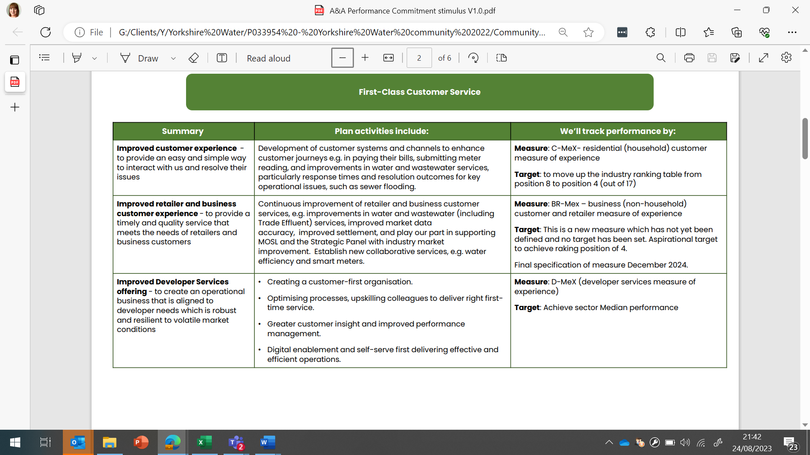
Based on what you have read, how supportive are you of the targets/performance commitments Yorkshire Water has set for this outcome overall?
Instruction text: Please select one
Page break: Yes
Title: Q24
Question type: Single Select
Randomisation: None
Implementation QID: Q24
Filter / routing information: No
Other potential instructions: No

Answer options | Precodes | Fix | Open | Screen
Very supportive | 1 | ☐ | ☐ | ☐
Fairly supportive | 2 | ☐ | ☐ | ☐
I don’t mind | 3 | ☐ | ☐ | ☐
Fairly unsupportive | 4 | ☐ | ☐ | ☐
Very unsupportive | 5 | ☐ | ☐ | ☐
I’m not sure | 6 | ☐ | ☐ | ☐

- Question text: Which of these targets in particular are you unsupportive of?
Click the image to enlarge or click here to open the image in a new window.

Instruction text: Please select all that apply
Page break: Yes
Title: Q25
Question type: Multi Select
Randomisation: None
Implementation QID: Q25
Filter / routing information: If Q24 = 4 or 5
Other potential instructions: No

Answer options | Precodes | Fix | Excl. | Open | Screen
Improved customer experience | 1 | ☐ | ☐ | ☐ | ☐
Improved retailer and business customer experience | 2 | ☐ | ☐ | ☐ | ☐
Improved Developer Services offering | 3 | ☐ | ☐ | ☐ | ☐
None specifically | 4 | ☐ | ☒ | ☐ | ☐
Unsure/ I don’t know | 5 | ☐ | ☒ | ☐ | ☐

- Question text: Please could you tell us a little bit here about why you are not supportive of the targets for this outcome?
Click the image to enlarge or click here to open the image in a new window

Page break: Yes
Title: Q26
Question type: Text
Implementation QID: ID here
Filter / routing information: If Q24 = 4 or 5
Other potential instructions: No

Answer options | Precodes | Fix | Screen
No idea | 1 | Fix | ☐

- Question text: Here are the measures & performance commitments that Yorkshire Water are proposing relating to the outcome ‘Bills everyone can afford.
Click the image to enlarge or click here to open the image in a new window.
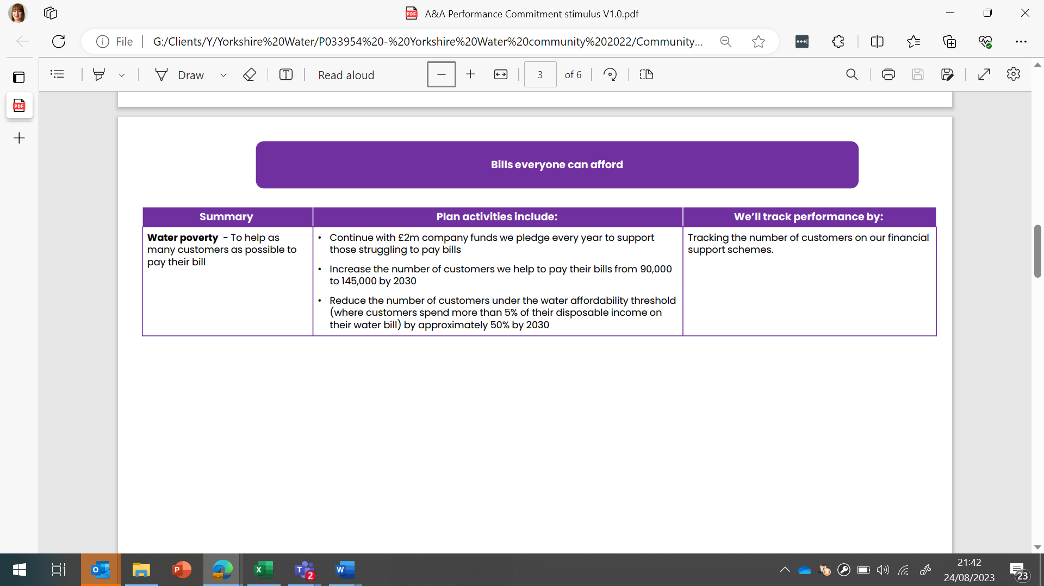
Based on what you have read, how supportive are you of the targets/performance commitments Yorkshire Water has set for this outcome overall?
Instruction text: Please select one
Page break: Yes
Title: Q27
Question type: Single Select
Randomisation: None
Implementation QID: Q27
Filter / routing information: No
Other potential instructions: No

Answer options | Precodes | Fix | Open | Screen
Very supportive | 1 | ☐ | ☐ | ☐
Fairly supportive | 2 | ☐ | ☐ | ☐
I don’t mind | 3 | ☐ | ☐ | ☐
Fairly unsupportive | 4 | ☐ | ☐ | ☐
Very unsupportive | 5 | ☐ | ☐ | ☐
I’m not sure | 6 | ☐ | ☐ | ☐

- Question text: Please could you tell us a little bit here about why you are not supportive of the targets for this outcome?
Click the image to enlarge or click here to open the image in a new window

Page break: Yes
Title: Q28
Question type: Text
Implementation QID: ID here
Filter / routing information: If Q27 = 4 or 5
Other potential instructions: No

Answer options | Precodes | Fix | Screen
No idea | 1 | Fix | ☐

- Question text: Here are the measures & performance commitments that Yorkshire Water are proposing relating to the outcome ‘Modern and sustainable infrastructure’.
Click the image to enlarge or click here to open the image in a new window.
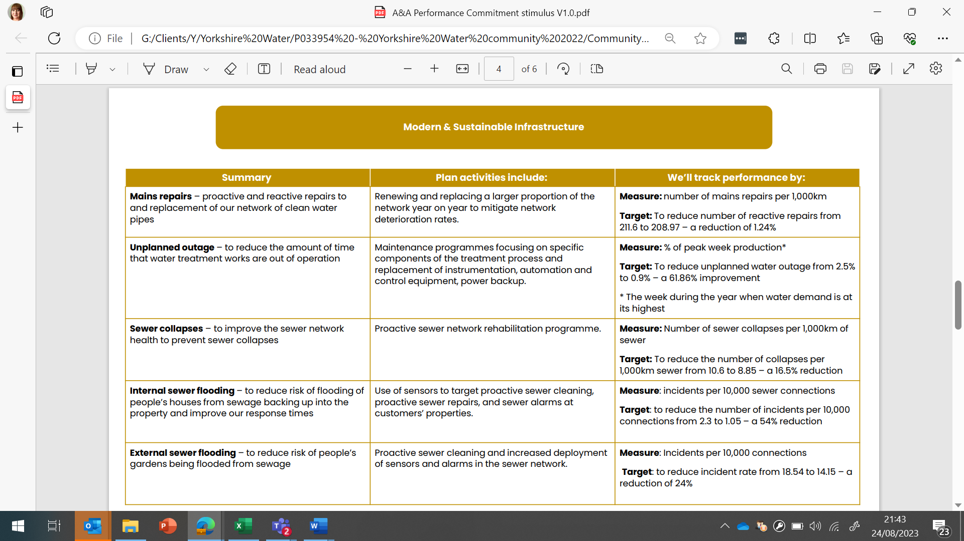
Based on what you have read, how supportive are you of the targets/performance commitments Yorkshire Water has set for this outcome overall?
Instruction text: Please select one
Page break: Yes
Title: Q29
Question type: Single Select
Randomisation: None
Implementation QID: Q34
Filter / routing information: No
Other potential instructions: No

Answer options | Precodes | Fix | Open | Screen
Very supportive | 1 | ☐ | ☐ | ☐
Fairly supportive | 2 | ☐ | ☐ | ☐
I don’t mind | 3 | ☐ | ☐ | ☐
Fairly unsupportive | 4 | ☐ | ☐ | ☐
Very unsupportive | 5 | ☐ | ☐ | ☐
I’m not sure | 6 | ☐ | ☐ | ☐

- Question text: Which of these targets in particular are you unsupportive of?
Click the image to enlarge or click here to open the image in a new window.

Instruction text: Please select all that apply
Page break: Yes
Title: Q30
Question type: Multi Select
Randomisation: None
Implementation QID: Q30
Filter / routing information: If Q29 = 4 or 5
Other potential instructions: No

Answer options | Precodes | Fix | Excl. | Open | Screen
Mains repairs | 1 | ☐ | ☐ | ☐ | ☐
Unplanned outages | 2 | ☐ | ☐ | ☐ | ☐
Sewer collapses | 3 | ☐ | ☐ | ☐ | ☐
Internal sewer flooding | 4 | ☐ | ☐ | ☐ | ☐
External sewer flooding | 5 | ☐ | ☐ | ☐ | ☐
None specifically | 6 | ☐ | ☒ | ☐ | ☐
Unsure/ I don’t know | 7 | ☐ | ☒ | ☐ | ☐

- Question text: Please could you tell us a little bit here about why you are not supportive of the targets for this outcome?
Click the image to enlarge or click here to open the image in a new window

Page break: Yes
Title: Q31
Question type: Text
Implementation QID: ID here
Filter / routing information: If Q29 = 4 or 5
Other potential instructions: No

Answer options | Precodes | Fix | Screen
No idea | 1 | Fix | ☐

- Question text: Here are the measures & performance commitments that Yorkshire Water are proposing relating to the outcome ‘Net zero carbon emissions’.
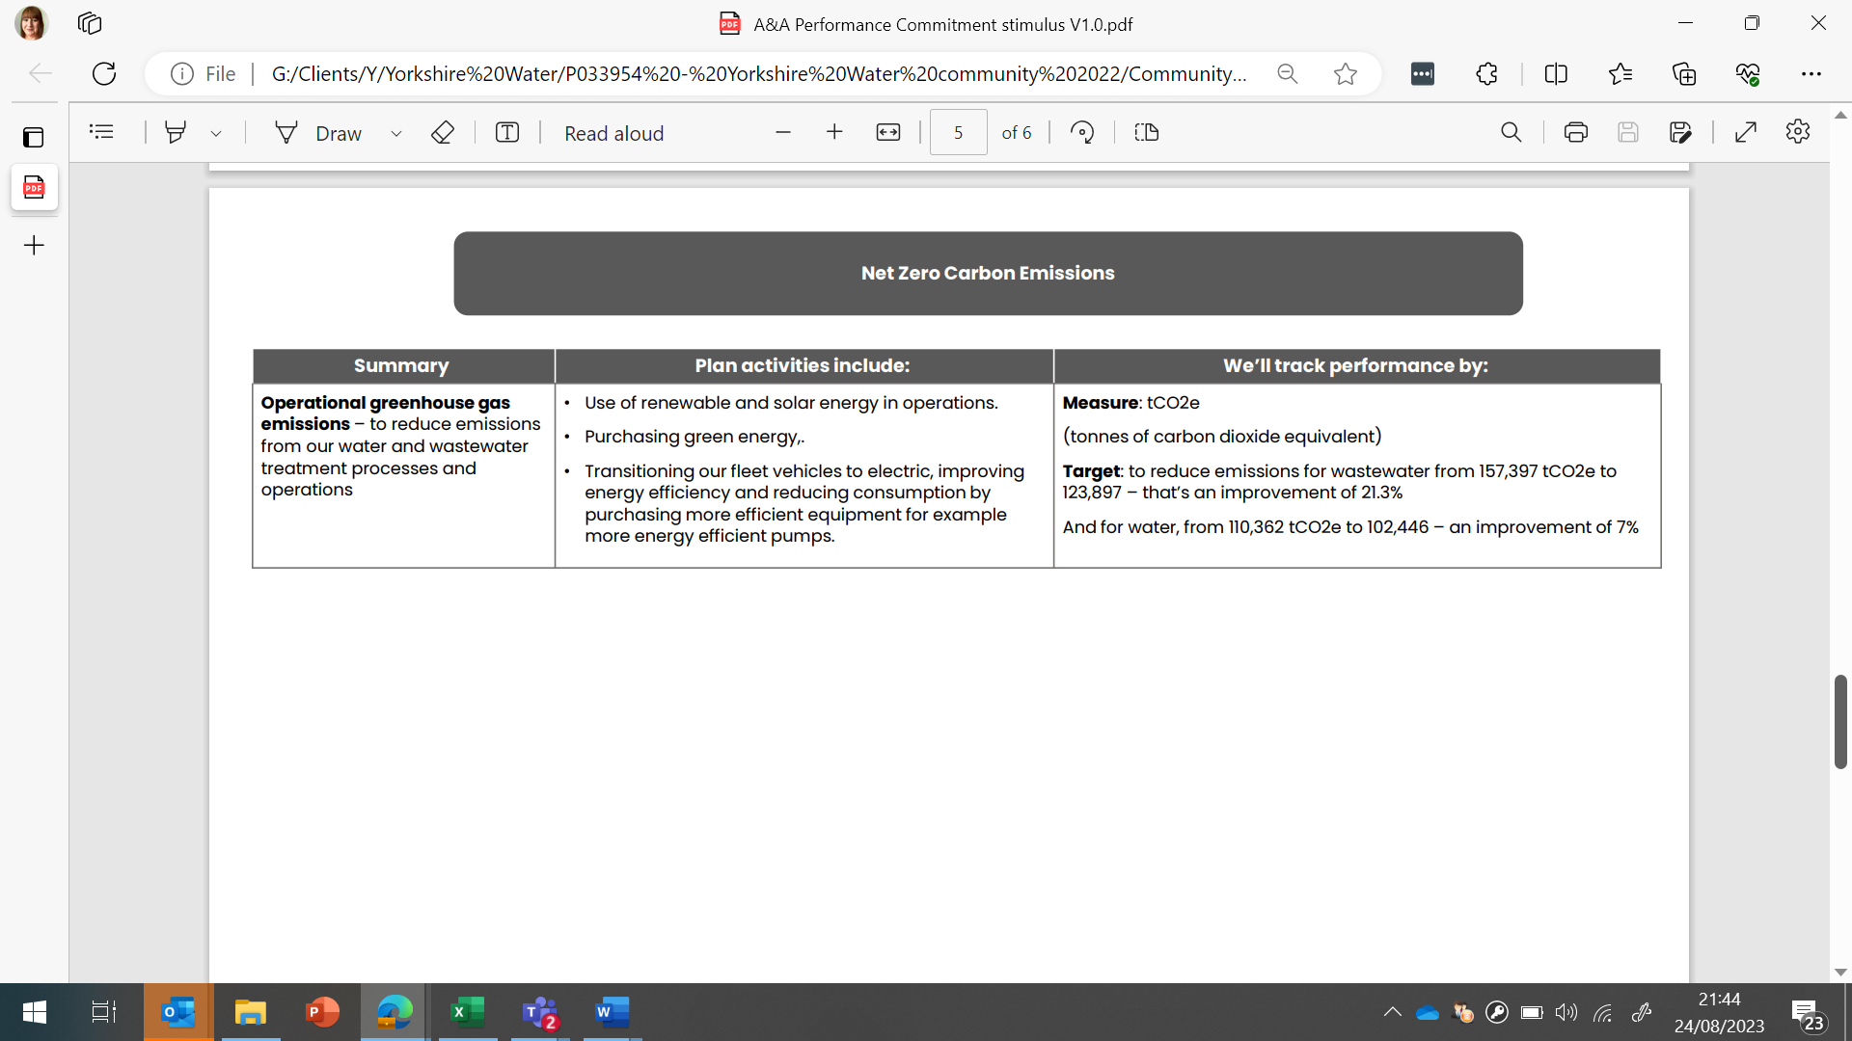
Click the image to enlarge or click here to open the image in a new window.
Based on what you have read, how supportive are you of the targets/performance commitments Yorkshire Water has set for this outcome overall?
Instruction text: Please select one
Page break: Yes
Title: Q32
Question type: Single Select
Randomisation: None
Implementation QID: Q32
Filter / routing information: No
Other potential instructions: No

Answer options | Precodes | Fix | Open | Screen
Very supportive | 1 | ☐ | ☐ | ☐
Fairly supportive | 2 | ☐ | ☐ | ☐
I don’t mind | 3 | ☐ | ☐ | ☐
Fairly unsupportive | 4 | ☐ | ☐ | ☐
Very unsupportive | 5 | ☐ | ☐ | ☐
I’m not sure | 6 | ☐ | ☐ | ☐

- Question text: Please could you tell us a little bit here about why you are not supportive of the targets for this outcome?
Click the image to enlarge or click here to open the image in a new window

Page break: Yes
Title: Q33
Question type: Text
Implementation QID: ID here
Filter / routing information: If Q32 = 4 or 5
Other potential instructions: No

Answer options | Precodes | Fix | Screen
No idea | 1 | Fix | ☐

- Question text: Here are the measures & performance commitments that Yorkshire Water are proposing relating to the outcome ‘A healthy, natural environment’.
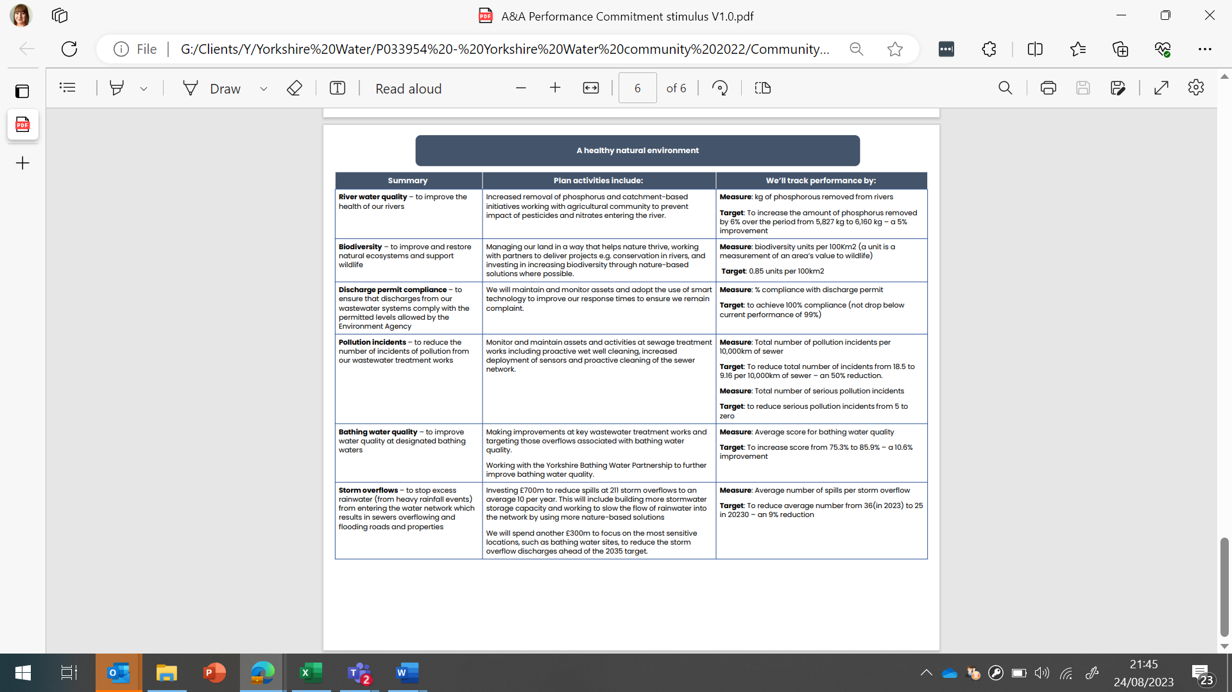
Click the image to enlarge or click here to open the image in a new window.
Based on what you have read, how supportive are you of the targets/performance commitments Yorkshire Water has set for this outcome overall?
Instruction text: Please select one
Page break: Yes
Title: Q34
Question type: Single Select
Randomisation: None
Implementation QID: Q39
Filter / routing information: No
Other potential instructions: No

Answer options | Precodes | Fix | Open | Screen
Very supportive | 1 | ☐ | ☐ | ☐
Fairly supportive | 2 | ☐ | ☐ | ☐
I don’t mind | 3 | ☐ | ☐ | ☐
Fairly unsupportive | 4 | ☐ | ☐ | ☐
Very unsupportive | 5 | ☐ | ☐ | ☐
I’m not sure | 6 | ☐ | ☐ | ☐

- Question text: Which of these targets in particular are you unsupportive of?
Click the image to enlarge or click here to open the image in a new window.

Instruction text: Please select all that apply
Page break: Yes
Title: Q35
Question type: Multi Select
Randomisation: None
Implementation QID: Q40
Filter / routing information: If Q34 = 4 or 5
Other potential instructions: No

Answer options | Precodes | Fix | Excl. | Open | Screen
River Water Quality | 1 | ☐ | ☐ | ☐ | ☐
Biodiversity | 2 | ☐ | ☐ | ☐ | ☐
Discharge permit compliance | 3 | ☐ | ☐ | ☐ | ☐
Pollution incidents | 6 | ☐ | ☐ | ☐ | ☐
Bathing water quality | 7 | ☐ | ☐ | ☐ | ☐
Storm overflows | 8 | ☐ | ☐ | ☐ | ☐
None specifically | 9 | ☐ | ☒ | ☐ | ☐
Unsure/ I don’t know | 10 | ☐ | ☒ | ☐ | ☒

- Question text: Please could you tell us a little bit here about why you are not supportive of the targets for this outcome?
Click the image to enlarge or click here to open the image in a new window

Page break: Yes
Title: Q36
Question type: Text
Implementation QID: ID here
Filter / routing information: If Q34= 4 or 5
Other potential instructions: No

Answer options | Precodes | Fix | Screen
No idea | 1 | Fix | ☐

SECTION 4: BILL IMPACT

- Question text: Currently, how much is your business’s annual bill for water and wastewater? Even if you only have a rough idea then please enter your best estimate below, or you can select ‘no idea’ if you’re unable to estimate this.
Instruction text: Please enter a rough amount that you believe your business pays over a year
Page break: Yes
Title: Q37
Question type: Number
Implementation QID: ID here Q22
Filter / routing information:
Other potential instructions: No

Answer options | Precodes | Fix | Screen
I have no idea how much my household’s annual water bill is | 1 | ☒ | ☐

- Question text:
Achieving all our targets and undertaking our biggest environmental programme yet from 2025-2030 will cost £8.6 billion overall. As a result, the average annual bill will increase from 2025-2030, a proportion of which will be due to inflation.
<Show if provided annual bill amount at Q37>
Below you can see an estimate of how much your annual bill is likely to be across those 5 years, based on the answer you gave to the last question.
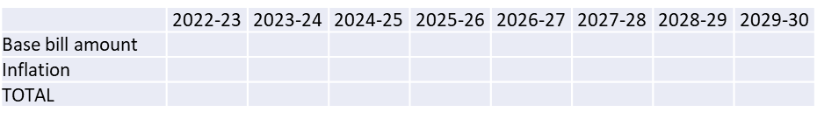

<Show if didn’t provide annual bill amount at Q37>
As a result, the average annual bill will increase by 25% from the current average bill across 2025-2030. In addition to this there will be an inflationary increase to your business’s bill, which is out of the control of Yorkshire Water, a forecasted inflation has been provided by Ofwat, this is added to your bill above. The inflation rate is a guide provided by Ofwat and is likely to change, inflation is out of the control of Yorkshire Water. If you’d like to read more about inflation, please click here [INSERT LINK TO OFWAT EXPLANATION]

<Show to all>
We have asked our customers the best and most manageable way to pay for the plan across the 5-year planning period and they have opted for a flat bill increase across the 5-year period (as opposed to a rising increase across the period).
You can find the detail of how your annual bill breaks down here (insert link to detailed bill breakdown). In summary, the average business customer bill from 2025-2030 will incorporate the following:
• Costs to maintain and improve our services - 90% of the bill
• Enhancement, including new statutory requirements - 8% of the bill
• Customer-supported enhancements - 1% of the bill
How easy or difficult do you think it would be for you to afford these water/sewerage bills in the future?
Instruction text: Please select one answer
Page break: Yes
Title: Q38
Question type: Single Code
Randomisation: REVERSE ORDER OF CODES 1 TO 5 Randomised
Implementation QID: Q38
Filter / routing information:
Other potential instructions: No

Scale options | Precodes | Fix
Very easy | 1 | ☐
Fairly easy | 2 | ☐
I don’t mind | 3 | ☐
Fairly difficult | 4 | ☐
Very difficult | 5 | ☐
Don’t know | 6 | ☒

- Question text: Why do you say that?
Instruction text: There are no right or wrong answers – please be as honest as possible!
Page break: No
Title: Q39
Question type: Essay
Implementation QID: Q39
Filter / routing information: No
Other potential instructions: No

- Question text: Long-term investment by Yorkshire Water will require an increase in customer bills. Bills could increase in different ways over time. For example, there could be increases now for current bill payers, or bigger increases in the long term for future generations. Which one of the following options would you prefer?
Instruction text: Please select one answer
Page break: Yes
Title: Q40
Question type: Single Code
Randomisation: Randomised
Implementation QID: Q40
Filter / routing information: No
Other potential instructions: No

Scale options | Precodes | Fix
An increase in bills starting sooner, spreading increases across different generations of bill-payers | 1 | ☐
An increase in bills starting later, putting more of the increases onto younger and future bill-payers | 2 | ☐
I don’t know enough at the moment to give an answer | 3 | ☐

- Question text: Why do you say that?
Instruction text: Please tell us a little bit about this below.
Page break: No
Title: Q41
Question type: Essay
Implementation QID: Q41
Filter / routing information: No
Other potential instructions: No

- Question text: Now for the final verdict - Based on everything you have seen and read about Yorkshire Water’s proposed business plan, how acceptable or unacceptable is it to you?
Instruction text: Please select one answer
Page break: Yes
Title: Q42
Question type: Single Code
Randomisation: REVERSE ORDER OF CODES 1 TO 5 None
Implementation QID: Q42
Filter / routing information: No
Other potential instructions: No

Scale options | Precodes | Fix
Completely acceptable | 1 | ☐
Acceptable | 2 | ☐
Unacceptable | 4 | ☐
Completely unacceptable | 5 | ☐
Don’t know / can’t say | 6 | ☒

- Question text: Why do you say that?
Instruction text: There are no right or wrong answers – please be as honest as possible!
Page break: Yes
Title: Q43
Question type: Essay
Implementation QID: Q43
Filter / routing information: No
Other potential instructions: No

Info Text: Thanks for taking part, that’s all we had to ask you today.
Please click continue to close the survey and submit your answers.
Page break: Yes
Title: ClosingThanks
Question type: Info
Implementation QID: ID here
Filter / routing information: No
Other potential instructions: No

