**Activity Guide**

**Yorkshire Water**

**LTDS**

Markets:   
**UK**

Human8 Team:   
**Paige Blake** [PaigeB@wearehuman8.com](mailto:PaigeB@wearehuman8.com)

**Sarah Fixter** [SarahF@wearehuman8.com](mailto:SarahF@wearehuman8.com)

Client Stakeholders:   
**Donna Hildreth**

**Naveed Majid**

**Jenna Spence**

Date:   
**25th July 2023**

**PROJECT DETAILS**

*Fill in information below.*

|  |  |
| --- | --- |
| **Research Approach** | |
| Data Collection Source(s): | **Your Water Community + Panel** |
| Questionnaire Length: | **10 - 15 minutes** |
| Project Type: | **Insight Generation** |
| Questionnaire Design: | **Cross sectional design** |
| **Markets, Languages & Translations** | |
| Markets & Languages per market: | **UK only** |
| **Sample Spec** |  |
| Total Sample |  |
| **SAMPLE GROUPS** | Community = no max. quota (send to whole community)  Panel = max. quota 500 |
| **Sample Screening** *(estimated incidence rate if known…%)* |  |
| Visual / Auditory Limitation allowed: | Yes |
| **Sample Quota(s)** |  |
| **APPLY TO PANEL ONLY (HV1 = CODE 2) Max quota n=500** |  |
| Age (Q2)   * 18-19 (N=26) * 20-29 (N=123) * 30-44 (N=134) * 45-59 (N=87) * 60-64 (N=24) * 65+ (N=109) |  |
| Gender (Q3)   * Male (N=277) * Female (N=223) |  |
| Region (Q5)   * West Yorkshire (N=234) * South Yorkshire (N=147) * North Yorkshire (N=80) * East Yorkshire (N=56) |  |
| SEG (HV5 SEG Combined)   * AB (N=165) * C1 (N=115) * C2 (N=100) * DE (N=120) |  |
| **Stimuli Overview** *(internal use only: stimuli requirements can be found here)* | |
|  |  |
| **G:\Clients\Y\Yorkshire Water\P033954 - Yorkshire Water community 2022\Community Content\Projects\07 23 LTDS\2. Plan\Stimuli** |  |
| **Mobile** | |
| The survey is drafted to be as: | **Mobile compatible** |

**PROJECT OBJECTIVES AND BACKGROUND INFORMATION**

|  |  |  |
| --- | --- | --- |
| **Background Business Objective** *(i.e., why is the research being done, what decisions are being made on the back of it, what’s led to research being part of the solution & what’s the business need for the research?)* | | |
| In April 2022, Ofwat released their final guidance outlining their expectations for water and sewage companies' long-term delivery strategies. The guidance was designed to help companies set their five-year business plans in the context of a 25-year long-term delivery strategy.  Yorkshire Water have created a long-term delivery strategy designed to ensure the resilience of our systems and to detail developments needed to meet water supply and wastewater needs of customers over the next 25 years. The LTDS has been developed in line with Ofwat’s guidance. It includes the statutory requirements for all water companies and where we intend to go beyond the requirements outlined by Ofwat. | | |
| **Research Objectives** *(i.e., what’s the research addressing, what behaviour is it hoping to understand in people, what decisions are being made on the back of the results that could not otherwise be made?)* | | |
| * To explore customers’ thoughts on the various aspects of our LTDS:   + - Vision     - Ambition     - Performance commitments and their targets     - Enhancement expenditure across AMPS.     - Bill impact   For each of the above its important to unearth: Is it clear what we want to achieve; are we going far enough/could we be doing more?; Is there anything missing?; Is there any parts of the plan customers feel are unnecessary?,;Are there any parts of the plan which could be delivered sooner?; do customers support our approach?   * To understand if customers believe our performance commitment targets and enhancement spend will ultimately achieve our LTDS Vision and Ambition. If not, why not, what could make this more convincing? * To determine the levels of support for our LTDS overall and the various aspects of the plan * To ascertain how affordable our customers believe the LTDS to be * To explore bill phasing; is one flat bill (excluding inflation) best across each five-year period or would customers prefer incremental bills within each planning cycle? * Within this, it's important to explore intergenerational fairness * Do customers trust YW to deliver this LTDS? If not, why and how can this perception be improved/changed. | | |
| **Key Project Timings** | | |
| **Project Stage** | **Timings** | **Responsible** |
| Activity Guide Signed Off | **02/08/2023** | **Client** |
| Scripting | **03/08/2023 - 04/08/2023** | **Human8** |
| Live | **07/08/2023 – 16/08/2023** | **Human8** |
| Data weighting | **17/08/2023** | **Human8** |
| Analysis & reporting | **18/08/2023 – 30/08/2023** | **Human8** |
| Report shared | **01/09/2023** | **Human8** |
| **Project Cost** | | |
| **£10,800** | | |

PROJECT INVITE (COMMUNITY)

|  |  |
| --- | --- |
| **Newsletter/Email Invite Copy** | |
| Subject: | **Tell us your thoughts on Yorkshire Water’s Long-Term Delivery Strategy** |
| **Hi <USERNAME>,**  **Yorkshire Water have developed a long-term delivery strategy (LTDS) that sets out all they wish to accomplish over the next 25 years. This has been developed in line with Ofwat’s guidance and includes the statutory requirements for all water companies, as well as where Yorkshire Water intend to go beyond this.**  **In today’s survey, we’d like you to share your thoughts on the Long-Term Delivery Strategy.**  **<Click here to take part>**  **All those taking part will be entered into a draw to win a share of £1500 (2x £250 Tremendous vouchers, 5x £100 Tremendous vouchers, 15 x £20 Tremendous vouchers, 20 x £10 Tremendous vouchers). You’ll also be entered into our usual monthly prize draw.**  **Thanks,**  **Paige & the Your Water team** | |
| Call to action button: | **Click here to take part** |

|  |  |
| --- | --- |
| **Activity Card** | |
| Card title: | **Tell us your thoughts on Yorkshire Water’s Long-Term Delivery Strategy** |
| Card text: | We’d like you to share your thoughts on Yorkshire Water’s Long-Term Delivery Strategy. All those taking part will be entered into a draw to win a share of £1500 (2x £250 Tremendous vouchers, 5x £100, 15x £20 Tremendous vouchers, 20x £10 Tremendous vouchers). |
| Image: | brown and green mountains under white sky during daytime |

**QUESTIONNAIRE**

*NB. Supporting text on all questions in the grey boxes is for internal use.*

**Hidden Question**: HV1 Sample Source

Page break: Yes

Title: HV1 Sample Source  
Question type: Hidden Variable

Randomisation: None

Implementation QID: HV1 Sample Source

Filter / routing information: Assign based on sample source

Other potential instructions: No

|  |  |  |  |
| --- | --- | --- | --- |
| Answer options | Precodes | Clarification | Screen |
| Community | 1 | If Your Water community |  |
| Panel | 2 | If third party panel |  |

|  |
| --- |
| **SECTION 1: PROFILING** |

**Info Text:** Thanks for joining us. Today we’d like to talk to you about Yorkshire Water’s Long Term Delivery Strategy.

Before we get started, we just need to ask you a few questions about yourself…

Page break: Yes

Title: Info1

Question type: Info

Implementation QID: Info1

Filter / routing information: No

Other potential instructions: No

1. Question text: Firstly, please could you let us know whether you’re responsible for paying towards the water bill in your home?

Instruction text: Please select one

Page break: Yes

Title: Q1  
Question type: Single Select

Randomisation: None

Implementation QID: Q1

Filter / routing information: No

Other potential instructions: No

|  |  |  |  |  |
| --- | --- | --- | --- | --- |
| Answer options | Precodes | Fix | Open | Screen |
| Yes, I am | 1 |  |  |  |
| No, I am not | 2 |  |  |  |
| Unsure | 3 |  |  |  |

1. Question text: Which of the following age groups do you fall into?

Instruction text: Please select one

Page break: Yes

Title: Q2  
Question type: Single Select

Randomisation: None

Implementation QID: Q2

Filter / routing information:

Other potential instructions: No

|  |  |  |  |  |
| --- | --- | --- | --- | --- |
| Answer options | Precodes | Fix | Open | Screen |
| Under 18 | 1 |  |  |  |
| 18-19 | 2 |  |  |  |
| 20-29 | 3 |  |  |  |
| 30-44 | 4 |  |  |  |
| 45-59 | 5 |  |  |  |
| 60-64 | 6 |  |  |  |
| 65+ | 7 |  |  |  |

**Info Text:** Thanks for taking part in this survey. Unfortunately we’re looking for people aged 18 or above, so we won’t take up anymore of your time today. Please click the ‘Finish Survey’ button to finish up.

Page break: Yes

Title: ClosingThanksAge

Question type: Info

Implementation QID: ClosingThanksAge

Filter / routing information:

Other potential instructions:

**Hidden Question**: HV2 Age NETS

Page break: Yes

Title: HV2 Age NETS  
Question type: Hidden Variable

Randomisation: None

Implementation QID: HV2 Age NETS

Filter / routing information: No

Other potential instructions: No

|  |  |  |  |
| --- | --- | --- | --- |
| Answer options | Precodes | Clarification | Screen |
| 18-29 | 1 | IF Q2 = CODE 2 OR 3 |  |
| 30-44 | 2 | IF Q2 = CODE 4 |  |
| 45-59 | 3 | IF Q2 = CODE 5 |  |
| 60+ | 4 | IF Q2 = CODE 6 OR 7 |  |

1. Question text: Which of the following do you identify as…?

Instruction text: Please select one

Page break: Yes

Title: Q3  
Question type: Single Select

Randomisation: None

Implementation QID: Q3

Filter / routing information:

Other potential instructions: No

|  |  |  |  |  |
| --- | --- | --- | --- | --- |
| Answer options | Precodes | Fix | Open | Screen |
| Female | 1 |  |  |  |
| Male | 2 |  |  |  |
| I identify in another way | 3 |  |  |  |
| Prefer not to say | 4 |  |  |  |

**Hidden Question**: HV3 Gender Combined

Page break: Yes

Title: HV3 Gender Combined  
Question type: Hidden Variable

Randomisation: None

Implementation QID: HV3 Gender Combined

Filter / routing information: Combine Q3 with community background variable “Gender”

Other potential instructions: No

|  |  |  |  |
| --- | --- | --- | --- |
| Answer options | Precodes | Clarification | Screen |
| Female | 1 | IF Q3 OR “GENDER” = CODE 1 |  |
| Male | 2 | IF Q3 OR “GENDER” = CODE 2 |  |
| Other | 3 | IF Q3 OR “GENDER” = CODE 3 |  |
| Prefer not to say | 4 | IF Q3 OR “GENDER” = CODE 4 |  |

1. Question text: Where do you live?

Instruction text: Please select one

Page break: Yes

Title: Q4  
Question type: Single Select

Randomisation: None

Implementation QID: Q4

Filter / routing information:

Other potential instructions: No

|  |  |  |  |  |
| --- | --- | --- | --- | --- |
| Answer options | Precodes | Fix | Open | Screen |
| Greater London | 1 |  |  |  |
| South East | 2 |  |  |  |
| East Anglia | 3 |  |  |  |
| South West | 4 |  |  |  |
| West Midlands | 5 |  |  |  |
| East Midlands | 6 |  |  |  |
| North West | 7 |  |  |  |
| Yorkshire & Humberside | 8 |  |  |  |
| North East | 9 |  |  |  |
| Wales | 10 |  |  |  |
| Scotland | 11 |  |  |  |
| Northern Ireland | 12 |  |  |  |
| Outside of the UK | 13 |  |  |  |

**Info Text:** Thanks for taking part in this survey. Unfortunately we’re looking to speak to people from certain areas, so we won’t take up any more of your time today. Please click the ‘Finish Survey’ button to finish up.

Page break: Yes

Title: ClosingThanksRegion

Question type: Info

Implementation QID: ClosingThanksRegion

Filter / routing information:

Other potential instructions:

1. Question text: In which area of Yorkshire do you live?

Instruction text: Please select one

Page break: Yes

Title: Q5  
Question type: Single Select

Randomisation: None

Implementation QID: Q5

Filter / routing information:

Other potential instructions: No

|  |  |  |  |  |
| --- | --- | --- | --- | --- |
| Answer options | Precodes | Fix | Open | Screen |
| West Yorkshire | 1 |  |  |  |
| South Yorkshire | 2 |  |  |  |
| East Riding of Yorkshire | 3 |  |  |  |
| North Yorkshire | 4 |  |  |  |

**Hidden Question**: HV4 Region Combined

Page break: Yes

Title: HV4 Region Combined  
Question type: Hidden Variable

Randomisation: None

Implementation QID: HV4 Region Combined

Filter / routing information: Combine Q5 with community background variable “Region”

Other potential instructions: No

|  |  |  |  |
| --- | --- | --- | --- |
| Answer options | Precodes | Clarification | Screen |
| West Yorkshire | 1 | IF Q5 OR “REGION” = CODE 1 |  |
| South Yorkshire | 2 | IF Q5 OR “REGION” = CODE 2 |  |
| East Riding of Yorkshire | 3 | IF Q5 OR “REGION” = CODE 3 |  |
| North Yorkshire | 4 | IF Q5 OR “REGION” = CODE 4 |  |

1. Question text: Does Yorkshire Water provide your water and wastewater services?

Instruction text: Please select the answer below that best applies

Page break: Yes

Title: Q6  
Question type: Single Select

Randomisation: None

Implementation QID: Q6

Filter / routing information: No

Other potential instructions: No

|  |  |  |  |  |
| --- | --- | --- | --- | --- |
| Answer options | Precodes | Fix | Open | Screen |
| Yes, they provide my **water and wastewater services** | 1 |  |  |  |
| They provide my **water** | 2 |  |  |  |
| They provide me with **wastewater services** | 3 |  |  |  |
| No, **they don’t provide** my water or wastewater | 4 |  |  |  |
| I don’t know | 5 |  |  |  |

**Info Text:** Thanks for taking part in this survey. Unfortunately we’re looking to speak to specific Yorkshire Water customers, so wewon’t take up any more of your time today. Please click the ‘Finish Survey’ button to finish up.

Page break: Yes

Title: ClosingThanksWaterSupplier

Question type: Info

Implementation QID: ClosingThanksWaterSupplier

Filter / routing information: IF Q6≠1 (NON-YW CUSTOMER)

Other potential instructions:

1. Question text: Have you ever worked for a water or wastewater provider?

Instruction text: Please select one

Page break: Yes

Title: Q7  
Question type: Single Select

Randomisation: None

Implementation QID: Q7

Filter / routing information:

Other potential instructions: No

|  |  |  |  |  |
| --- | --- | --- | --- | --- |
| Answer options | Precodes | Fix | Open | Screen |
| Yes – I currently work for a water or wastewater provider | 1 |  |  |  |
| Yes – I previously worked for a water or wastewater provider within the past year | 2 |  |  |  |
| Yes – I previously worked for a water or wastewater provider over a year ago | 3 |  |  |  |
| No – I’ve never worked for a water or wastewater provider | 4 |  |  |  |

**Info Text:** Thanks for taking part in this survey. Unfortunately we’re looking for people who don’t currently, or haven’t recently, worked for a water provider, so we won’t take up anymore of your time today. Please click the ‘Finish Survey’ button to finish up.

Page break: Yes

Title: ClosingThanksJob

Question type: Info

Implementation QID: ClosingThanksJob

Filter / routing information: IF Q7 = CODE 1 OR 2 (WORKED IN WATER INDUSTY)

Other potential instructions:

1. Question text: Please indicate to which occupational group the chief income earner in your household belongs, or which group fits best. This could be you or someone else: the chief income earner is the person in your household with the largest income.

If the chief income earner is retired and has an occupational pension please answer for the occupation which was their main career.

If the chief income earner is not in paid employment but has been out of work for less than 6 months, please answer for their most recent occupation.

Instruction text: Please select one

Page break: Yes

Title: Q8  
Question type: Single Select

Randomisation: None

Implementation QID: Q8

Filter / routing information: No

Other potential instructions: No

|  |  |  |  |  |
| --- | --- | --- | --- | --- |
| Answer options | Precodes | Fix | Open | Screen |
| Higher managerial, administrative or professional e.g. doctor, lawyer, medium / large company director (50+ people) | 1 |  |  |  |
| Intermediate managerial, administrative or professional e.g. teacher, manager, accountant | 2 |  |  |  |
| Supervisor, administrative or professional e.g. police officer, nurse, secretary, self-employed | 3 |  |  |  |
| Skilled manual worker e.g. mechanic, plumber, electrician, lorry driver, train driver | 4 |  |  |  |
| Semi-skilled or unskilled manual work e.g. waiter, factory worker, receptionist, labourer | 5 |  |  |  |
| Housewife/ househusband | 6 |  |  |  |
| Unemployed | 7 |  |  |  |
| Student | 8 |  |  |  |
| Retired | 9 |  |  |  |

**Hidden Question**: HV5 SEG Combined

Page break: Yes

Title: HV5 SEG Combined  
Question type: Hidden Variable

Randomisation: None

Implementation QID: HV5 SEG Combined

Filter / routing information: No

Other potential instructions: No

|  |  |  |  |
| --- | --- | --- | --- |
| Answer options | Precodes | Clarification | Screen |
| AB | 1 | IF Q8 = CODE 1 OR 2 |  |
| C1 | 2 | IF Q8 = CODE 3 OR 8 |  |
| C2 | 3 | IF Q8 = CODE 4 |  |
| DE | 4 | IF Q8 = CODE 5, 6, 7 or 9 |  |

1. Question text: Which of the following apply to you and your household?

Instruction text: Please select all that apply

Page break: Yes

Title: Q9  
Question type: Multi Select

Randomisation: None

Implementation QID: Q9

Filter / routing information: No

Other potential instructions: No

|  |  |  |  |  |  |
| --- | --- | --- | --- | --- | --- |
| Answer options | Precodes | Fix | Excl. | Open | Screen |
| I or another member of my household is disabled or suffer(s) from a debilitating illness | 1 |  |  |  |  |
| I or another member of my household have/has a learning difficulty | 2 |  |  |  |  |
| I or another member of my household relies on water for medical reasons | 3 |  |  |  |  |
| I or another member of my household is visually impaired (i.e. struggles to read even with glasses) | 4 |  |  |  |  |
| I or another member of my household am/is over the age of 75 years old | 5 |  |  |  |  |
| I or another member of my household speaks English as a second language | 6 |  |  |  |  |
| I/our household often struggle to afford household/utility bills | 7 |  |  |  |  |
| I or another member of my household is deaf or hard of hearing | 8 |  |  |  |  |
| I or another member of my household is a new parent | 9 |  |  |  |  |
| None of the above | 99 |  |  |  |  |

**Hidden Question**: HV6 Vulnerability Combined

Page break: Yes

Title: HV6 Vulnerability Combined  
Question type: Hidden Variable

Randomisation: None

Implementation QID: HV6 Vulnerability Combined

Filter / routing information: No

Other potential instructions: No

|  |  |  |  |
| --- | --- | --- | --- |
| Answer options | Precodes | Clarification | Screen |
| Vulnerable customer | 1 | IF Q9 = CODE 1-9 |  |
| Non-vulnerable customer | 2 | IF Q9 = CODE 99 |  |

**Hidden Question**: HV7 Financial Vulnerability Combined

Page break: Yes

Title: HV7 Financial Vulnerability Combined  
Question type: Hidden Variable

Randomisation: None

Implementation QID: HV7 Financial Vulnerability Combined

Filter / routing information: No

Other potential instructions: No

|  |  |  |  |
| --- | --- | --- | --- |
| Answer options | Precodes | Clarification | Screen |
| Financially vulnerable | 1 | IF Q9 = CODE 7 |  |
| Non-financially vulnerable | 2 | IF Q9 ≠ CODE 7 |  |

1. Question text: Thinking about your household finances in 2023, how would you describe your financial situation at the moment?

Instruction text: Please select the option below that best applies.

Page break: Yes

Title: Q10  
Question type: Single Select

Randomisation: None

Implementation QID: Q10

Filter / routing information: No

Other potential instructions: No

|  |  |  |  |  |
| --- | --- | --- | --- | --- |
| Answer options | Precodes | Fix | Open | Screen |
| I can easily cover the basics, plus I have a good amount left for luxuries or to add to my savings each month | 1 |  |  |  |
| I can comfortably cover the basics, though I have only a limited amount left over | 2 |  |  |  |
| I’m making ends meet, but only just | 3 |  |  |  |
| I’m in danger of falling behind with bills or loan repayments | 4 |  |  |  |
| I’ve missed loan repayments or household bills | 5 |  |  |  |
| Prefer not to say | 6 |  |  |  |

1. Question text: Do you have a water meter?

Instruction text: Please select one

Page break: Yes

Title: Q11  
Question type: Single Select

Randomisation: None

Implementation QID: Q11

Filter / routing information:

Other potential instructions: No

|  |  |  |  |  |
| --- | --- | --- | --- | --- |
| Answer options | Precodes | Fix | Open | Screen |
| Yes | 1 |  |  |  |
| No | 2 |  |  |  |
| Don’t know | 3 |  |  |  |

**Hidden Question**: HVWaterMeter

Page break: Yes

Title: HVWaterMeter  
Question type: Hidden Variable

Randomisation: None

Implementation QID: ID here

Filter / routing information: Combine Q11 with community background variable “Metred/Non Metred Customer”

Other potential instructions: No

|  |  |  |  |
| --- | --- | --- | --- |
| Answer options | Precodes | Clarification | Screen |
| Metred | 1 | IF Q11 = CODE 1 OR ‘METRED/NON METRED CUSTOMER’ = CODE 1 |  |
| Non-metred | 2 | IF Q11 = CODE 2 OR ‘METRED/NON METRED CUSTOMER’ = CODE 2 |  |
| Don’t know | 3 | IF Q11 = CODE 3 OR ‘METRED/NON METRED CUSTOMER’ = CODE 3 OR UNKNOWN |  |

|  |
| --- |
| **SECTION 2: OVERALL VISION** |

**Info Text:** Thanks for your input so far.

The water industry faces a series of long-term challenges, such as climate change and population growth. To meet these challenges, Ofwat (the water industry regulator) have asked companies to set out their five-year business plan in the context of a 25-year Long Term Delivery Strategy.

Yorkshire Water have created a Long Term Delivery Strategy designed to ensure the resilience of their service and to outline what is needed to meet water supply and wastewater needs of customers over the next 25 years.

The Long Term Delivery Strategy has been developed in line with Ofwat’s guidance. It includes the statutory requirements for all water companies. The Long Term Delivery Strategy sets out all Yorkshire Water wish to accomplish over the next 25 years.

A significant environmental programme must be delivered by law over the coming 25 years, the Long Term Delivery Strategy is very much focused on delivering this, this is the main driver of cost and therefore the main impact to customers bills.

Page break: Yes

Title: IntroLTDS

Question type: Info

Implementation QID: IntroLTDS

Filter / routing information: No

Other potential instructions: No

1. Question text: Below you will see Yorkshire Water’s Long-Term Delivery Strategy vision:

“A thriving Yorkshire: right for our customers, and right for the environment.”

‘A thriving Yorkshire’ means operating in a region famous for its stunning beauty and natural environment, where communities can grow and prosper in a flourishing economy. Where anchor institutions like Yorkshire Water invest in infrastructure, create jobs, and support skills development and education – and work in partnership with other organisations across the region to achieve common goals such as flood management and prevention.

‘Right for our customers’ means that we will provide safe, clean, great tasting water and return wastewater safely to the environment. In providing these services we will make sure we deliver good value for money, which will mean bills that everyone can afford. We also know that our customers have a diverse range of needs, so we will provide first-class customer service and make sure that we are easy to deal with.

‘Right for the environment’ means taking care of our precious natural resources and carefully managing our impact on the natural environment of Yorkshire. We know that our first priority is preventing harm to the environment and to keep wastewater in the pipes. We must also protect our water resources, reduce our carbon emissions to net zero, and invest in modern and sustainable infrastructure.

To what extent do you agree or disagree with the following statements about the Long-Term Delivery Strategy vision…?

Instruction text: Please click on the buttons to rate the statements

Page break: Yes

Title: Q12  
Question type: Rating Scale

Randomisation: Randomised

Implementation QID: Q12

Filter / routing information: No

Other potential instructions: No

|  |  |  |  |
| --- | --- | --- | --- |
| Answer options | Precodes | Fix | Open |
| I like this overall vision | 1 |  |  |
| The vision reflects my priorities as a customer | 2 |  |  |
| The vision is clear | 3 |  |  |
| The vision covers the main areas I would expect | 4 |  |  |
| The vision seems realistic and achievable | 5 |  |  |
| The vision will benefit Yorkshire | 6 |  |  |
| I trust Yorkshire Water to deliver this vision | 7 |  |  |

|  |  |  |
| --- | --- | --- |
| Scale options | Precodes | Fix |
| Strongly agree | 1 |  |
| Somewhat agree | 2 |  |
| Neither agree nor disagree | 3 |  |
| Somewhat disagree | 4 |  |
| Strongly disagree | 5 |  |

1. Question text: Is there anything you like or dislike about the Long-Term Delivery Strategy vision?

“A thriving Yorkshire: right for our customers, and right for the environment.”

‘A thriving Yorkshire’ means operating in a region famous for its stunning beauty and natural environment, where communities can grow and prosper in a flourishing economy. Where anchor institutions like Yorkshire Water invest in infrastructure, create jobs, and support skills development and education – and work in partnership with other organisations across the region to achieve common goals such as flood management and prevention.

‘Right for our customers’ means that we will provide safe, clean, great tasting water and return wastewater safely to the environment. In providing these services we will make sure we deliver good value for money, which will mean bills that everyone can afford. We also know that our customers have a diverse range of needs, so we will provide first-class customer service and make sure that we are easy to deal with.

‘Right for the environment’ means taking care of our precious natural resources and carefully managing our impact on the natural environment of Yorkshire. We know that our first priority is preventing harm to the environment and to keep wastewater in the pipes. We must also protect our water resources, reduce our carbon emissions to net zero, and invest in modern and sustainable infrastructure.

Instruction text: There are no right or wrong answers – please be as honest as possible!

Page break: Yes

Title: Q13  
Question type: Essay

Implementation QID: Q13

Filter / routing information: No

Other potential instructions: No

|  |
| --- |
|  |

|  |
| --- |
| **SECTION 3: OUTCOMES** |

1. Question text: There are 6 outcomes that Yorkshire Water is striving to achieve in order to deliver its overall vision. You can see these below. Please click on the image to enlarge.

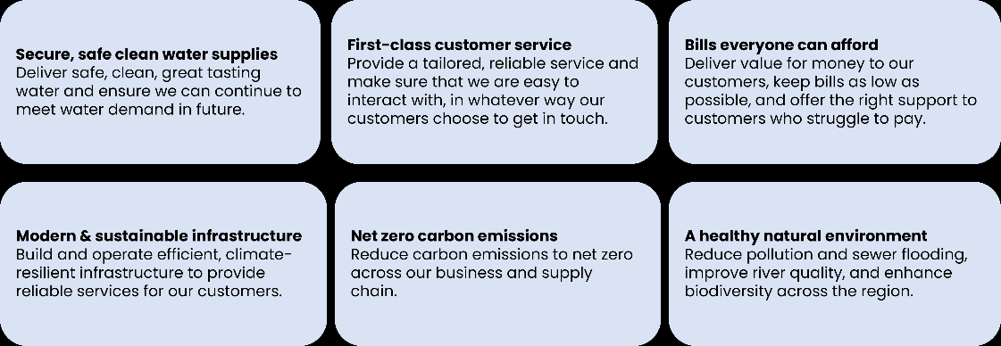

To what extent do you agree or disagree with the following statements about the Long-Term Delivery Strategy outcomes…?

Instruction text: Please click on the buttons to rate the statements

Page break: Yes

Title: Q14  
Question type: Rating Scale

Randomisation: None

Implementation QID: Q14

Filter / routing information: No

Other potential instructions: No

|  |  |  |  |
| --- | --- | --- | --- |
| Answer options | Precodes | Fix | Open |
| I like the overall outcomes | 1 |  |  |
| The outcomes reflect my priorities as a customer | 2 |  |  |
| The outcomes are clear | 3 |  |  |
| The outcomes cover the main areas I would expect | 4 |  |  |
| The outcomes seem realistic and achievable | 5 |  |  |
| The outcomes will benefit Yorkshire | 6 |  |  |
| I trust Yorkshire Water to deliver these outcomes | 7 |  |  |

|  |  |  |
| --- | --- | --- |
| Scale options | Precodes | Fix |
| Strongly agree | 1 |  |
| Somewhat agree | 2 |  |
| Neither agree nor disagree | 3 |  |
| Somewhat disagree | 4 |  |
| Strongly disagree | 5 |  |

1. Question text: Are there any outcomes that you don’t think should be included as part of the Long-Term Delivery Strategy? Please click on the image to enlarge.



Instruction text: Please select all that apply

Page break: Yes

Title: Q15  
Question type: Multi Select

Randomisation: None

Implementation QID: Q15

Filter / routing information: No

Other potential instructions: No

|  |  |  |  |  |  |
| --- | --- | --- | --- | --- | --- |
| Answer options | Precodes | Fix | Excl. | Open | Screen |
| Secure, safe clean water supplies | 1 |  |  |  |  |
| First-class customer service | 2 |  |  |  |  |
| Bills everyone can afford | 3 |  |  |  |  |
| Modern & sustainable infrastructure | 4 |  |  |  |  |
| Net zero carbon emissions | 5 |  |  |  |  |
| Looking after our natural environment | 6 |  |  |  |  |
| None, I think they should all be included | 7 |  |  |  |  |

1. Question text: Please tell us anything you like or dislike or if there is anything missing from the Long-Term Delivery Strategy outcomes?

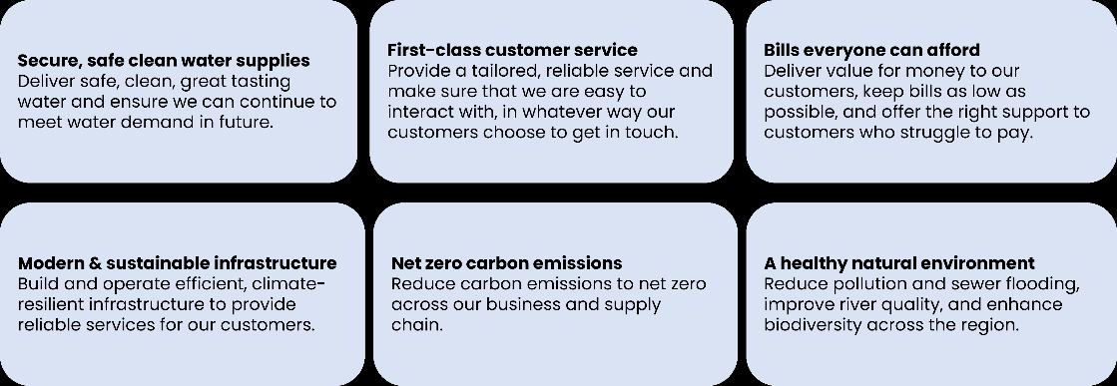

Instruction text: There are no right or wrong answers – please be as honest as possible!

Page break: Yes

Title: Q16  
Question type: Essay

Implementation QID: Q16

Filter / routing information: No

Other potential instructions: No

|  |
| --- |
|  |

16b. Question text: As you’ve seen, long term investment by Yorkshire Water will require an increase in customer bills. Bills could increase in different ways over time. For example, there could be increases now for current bill payers, or bigger increases in the long term for future generations. Which one of the following options would you prefer?

Instruction text: Select one

Page break: Yes

Title: Q16b  
Question type: Single Select

Randomisation: Randomised Rows

Implementation QID: ID here

Filter / routing information: No

Other potential instructions: No

|  |  |  |  |  |
| --- | --- | --- | --- | --- |
| Answer options | Precodes | Fix | Open | Screen |
| An increase in bills starting sooner, spreading increases across different generations of bill-payers | 1 |  |  |  |
| An increase in bills starting later, putting more of the increases onto younger and future bill-payers | 2 |  |  |  |
| I don’t know enough at the moment to give an answer | 3 |  |  |  |

|  |
| --- |
| **SECTION 4: TARGETS** |

**Info Text:** Thank you for your feedback so far.

Within each of the outcomes, there are some targets that enable Yorkshire Water to measure their performance.

For this next section, we’re going to show you the targets for each of the 6 outcomes. This might feel a little repetitive but please stick with us! This is so important to Yorkshire Water and will impact what you are paying for in the long run.

Page break: Yes

Title: InfoTarget

Question type: Info

Implementation QID: InfoTarget

Filter / routing information: No

Other potential instructions: No

**Hidden Question**: HV Target Order

Page break: Yes

Title: HV Target Order  
Question type: Hidden Variable

Randomisation: None

Implementation QID: HV Target Order

Filter / routing information: Respondents to see all sections. Randomise order shown sections.

Other potential instructions: No

|  |  |
| --- | --- |
| Answer options | Precodes |
| Secure, safe clean water supplies (Q17, Q18 & Q19) | 1 |
| First class customer service (Q20, Q21 & Q22) | 2 |
| Bills everyone can afford (Q23, Q24 & Q25) | 3 |
| Modern and sustainable infrastructure (Q26, Q27 & Q28) | 4 |
| Net zero carbon emissions (Q29 & Q30) | 5 |
| Looking after our natural environment (Q31, Q32 & Q33) | 6 |

|  |
| --- |
| **Secure, safe clean water supplies** |

1. Question text: Here are the measures & targets relating to the outcome ‘Secure, safe clean water supplies’.

Click the image to enlarge or click here to open the image in a new window.

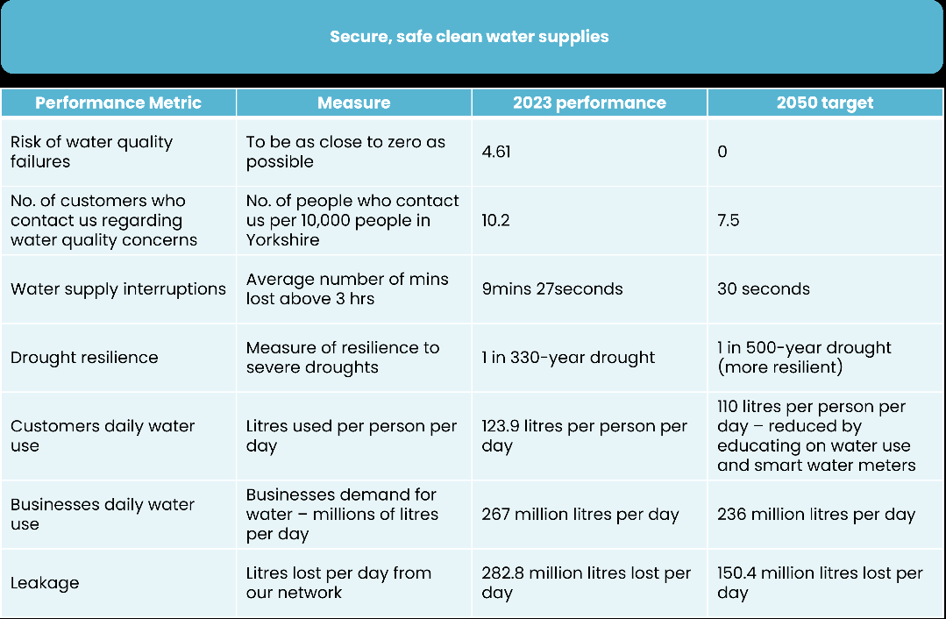

Based on what you have read, how supportive are you of the targets Yorkshire Water has set for this outcome overall?

Instruction text: Please select one

Page break: Yes

Title: Q17  
Question type: Single Select

Randomisation: None

Implementation QID: Q17

Filter / routing information: No

Other potential instructions: No

|  |  |  |  |  |
| --- | --- | --- | --- | --- |
| Answer options | Precodes | Fix | Open | Screen |
| Very supportive | 1 |  |  |  |
| Fairly supportive | 2 |  |  |  |
| Neutral | 3 |  |  |  |
| Fairly unsupportive | 4 |  |  |  |
| Very unsupportive | 5 |  |  |  |
| I’m not sure | 6 |  |  |  |

1. Question text: Are there any targets you feel are not going far enough?

Click the image to enlarge or click here to open the image in a new window.



Instruction text: Please select all that apply

Page break: Yes

Title: Q18  
Question type: Multi Select

Randomisation: None

Implementation QID: Q18

Filter / routing information: No

Other potential instructions: No

|  |  |  |  |  |  |
| --- | --- | --- | --- | --- | --- |
| Answer options | Precodes | Fix | Excl. | Open | Screen |
| Risk of water quality failures | 1 |  |  |  |  |
| No. of customers who contact us regarding water quality concerns | 2 |  |  |  |  |
| Water supply interruptions | 3 |  |  |  |  |
| Drought resilience | 4 |  |  |  |  |
| Customers daily water use | 5 |  |  |  |  |
| Businesses daily water use | 6 |  |  |  |  |
| Leakage | 7 |  |  |  |  |
| None, I think all the targets are acceptable | 99 |  |  |  |  |
| Unsure/ I don’t know | 100 |  |  |  |  |

1. Question text: You mentioned some targets were not going far enough, please tell us why and what you might expect them to be?

Click the image to enlarge or click here to open the image in a new window.



Instruction text:

Page break: Yes

Title: Q19  
Question type: Essay

Implementation QID: Q19

Filter / routing information: IF Q18≠ CODE 99 OR 100

Other potential instructions: No

|  |  |  |  |
| --- | --- | --- | --- |
| Answer options | Precodes | Fix | Screen |
| I don’t know | 1 | Fix |  |

|  |
| --- |
| **First-class customer service** |

1. Question text: Here are the measures & targets relating to the outcome ‘First-class customer service’.

Click the image to enlarge or click here to open the image in a new window.

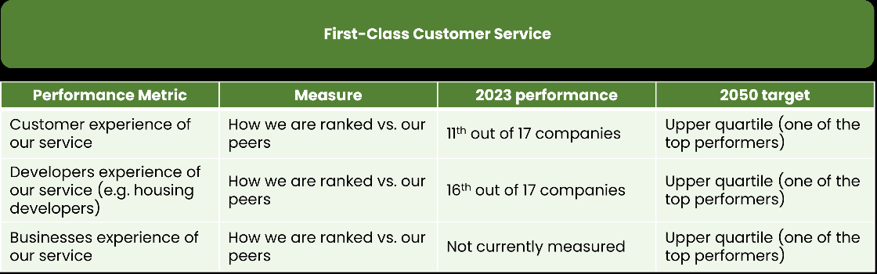

Based on what you have read, how supportive are you of the targets Yorkshire Water has set for this outcome overall?

Instruction text: Please select one

Page break: Yes

Title: Q20  
Question type: Single Select

Randomisation: None

Implementation QID: Q20

Filter / routing information: No

Other potential instructions: No

|  |  |  |  |  |
| --- | --- | --- | --- | --- |
| Answer options | Precodes | Fix | Open | Screen |
| Very supportive | 1 |  |  |  |
| Fairly supportive | 2 |  |  |  |
| Neutral | 3 |  |  |  |
| Fairly unsupportive | 4 |  |  |  |
| Very unsupportive | 5 |  |  |  |
| I’m not sure | 6 |  |  |  |

1. Question text: Are there any targets you feel are not going far enough?

Click the image to enlarge or click here to open the image in a new window.



Instruction text: Please select all that apply

Page break: Yes

Title: Q21  
Question type: Multi Select

Randomisation: None

Implementation QID: Q21

Filter / routing information: No

Other potential instructions: No

|  |  |  |  |  |  |
| --- | --- | --- | --- | --- | --- |
| Answer options | Precodes | Fix | Excl. | Open | Screen |
| Customer experience of our service | 1 |  |  |  |  |
| Developers experience of our service | 2 |  |  |  |  |
| Businesses experience of our service | 3 |  |  |  |  |
| None, I think all the targets are acceptable | 99 |  |  |  |  |
| Unsure/ I don’t know | 100 |  |  |  |  |

1. Question text: You mentioned some targets were not going far enough, please tell us why and what you might expect them to be?

Click the image to enlarge or click here to open the image in a new window.



Instruction text:

Page break: Yes

Title: Q22  
Question type: Essay

Implementation QID: Q22

Filter / routing information: IF Q21≠ CODE 99 OR CODE 100

Other potential instructions: No

|  |  |  |  |
| --- | --- | --- | --- |
| Answer options | Precodes | Fix | Screen |
| I don’t know | 1 | Fix |  |

|  |
| --- |
| **Bills everyone can afford** |

1. Question text: Here are the measures & targets relating to the outcome ‘Bills everyone can afford’.

Click the image to enlarge or click here to open the image in a new window.

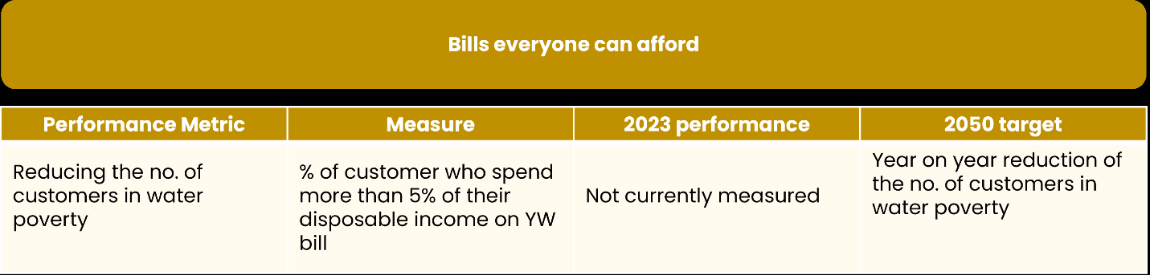

Based on what you have read, how supportive are you of the targets Yorkshire Water has set for this outcome overall?

Instruction text: Please select one

Page break: Yes

Title: Q23  
Question type: Single Select

Randomisation: None

Implementation QID: Q23

Filter / routing information: No

Other potential instructions: No

|  |  |  |  |  |
| --- | --- | --- | --- | --- |
| Answer options | Precodes | Fix | Open | Screen |
| Very supportive | 1 |  |  |  |
| Fairly supportive | 2 |  |  |  |
| Neutral | 3 |  |  |  |
| Fairly unsupportive | 4 |  |  |  |
| Very unsupportive | 5 |  |  |  |
| I’m not sure | 6 |  |  |  |

1. Question text: Are there any targets you feel are not going far enough?

Click the image to enlarge or click here to open the image in a new window.



Instruction text: Please select all that apply

Page break: Yes

Title: Q24  
Question type: Single Select

Randomisation: None

Implementation QID: Q24

Filter / routing information: No

Other potential instructions: No

|  |  |  |  |  |
| --- | --- | --- | --- | --- |
| Answer options | Precodes | Fix | Open | Screen |
| Reducing the no. of customers in water poverty | 1 |  |  |  |
| None, I think all the targets are acceptable | 99 |  |  |  |
| Unsure/ I don’t know | 100 |  |  |  |

1. Question text: You mentioned some targets were not going far enough, please tell us why and what you might expect them to be?

Click the image to enlarge or click here to open the image in a new window.



Instruction text:

Page break: Yes

Title: Q25  
Question type: Essay

Implementation QID: Q25

Filter / routing information: IF Q24 = CODE 1

Other potential instructions: No

|  |  |  |  |
| --- | --- | --- | --- |
| Answer options | Precodes | Fix | Screen |
| I don’t know | 1 | Fix |  |

|  |
| --- |
| **Modern and sustainable infrastructure** |

1. Question text: Here are the measures & targets relating to the outcome ‘Modern and sustainable infrastructure’.

Click the image to enlarge or click here to open the image in a new window.

Based on what you have read, how supportive are you of the targets Yorkshire Water has set for this outcome overall?

Instruction text: Please select one

Page break: Yes

Title: Q26  
Question type: Single Select

Randomisation: None

Implementation QID: Q26

Filter / routing information: No

Other potential instructions: No

|  |  |  |  |  |
| --- | --- | --- | --- | --- |
| Answer options | Precodes | Fix | Open | Screen |
| Very supportive | 1 |  |  |  |
| Fairly supportive | 2 |  |  |  |
| Neutral | 3 |  |  |  |
| Fairly unsupportive | 4 |  |  |  |
| Very unsupportive | 5 |  |  |  |
| I’m not sure | 6 |  |  |  |

1. Question text: Are there any targets you feel are not going far enough?

Click the image to enlarge or click here to open the image in a new window.

Instruction text: Please select all that apply

Page break: Yes

Title: Q27  
Question type: Multi Select

Randomisation: None

Implementation QID: Q27

Filter / routing information: No

Other potential instructions: No

|  |  |  |  |  |  |
| --- | --- | --- | --- | --- | --- |
| Answer options | Precodes | Fix | Excl. | Open | Screen |
| Internal sewer flooding | 1 |  |  |  |  |
| External sewer flooding | 2 |  |  |  |  |
| Sewer flooding risk | 3 |  |  |  |  |
| Mains repair | 4 |  |  |  |  |
| Sewer collapses | 5 |  |  |  |  |
| Unplanned outage | 6 |  |  |  |  |
| Discharge permit compliance | 7 |  |  |  |  |
| None, I think all the targets are acceptable | 99 |  |  |  |  |
| Unsure/ I don’t know | 100 |  |  |  |  |

1. Question text: You mentioned some targets were not going far enough, please tell us why and what you might expect them to be?

Click the image to enlarge or click here to open the image in a new window.

Instruction text:

Page break: Yes

Title: Q28  
Question type: Essay

Implementation QID: Q28

Filter / routing information: IF Q27≠ CODE 99 OR CODE 100

Other potential instructions: No

|  |  |  |  |
| --- | --- | --- | --- |
| Answer options | Precodes | Fix | Screen |
| I don’t know | 1 | Fix |  |

|  |
| --- |
| **Net zero carbon emissions** |

1. Question text: Here are the measures & targets relating to the outcome ‘Net zero carbon emissions’.

Click the image to enlarge or click here to open the image in a new window.

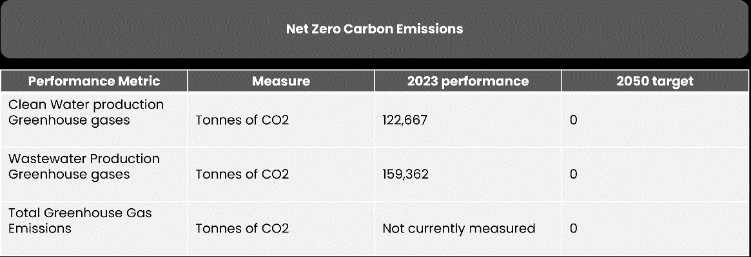

Based on what you have read, how supportive are you of the targets Yorkshire Water has set for this outcome overall?

Instruction text: Please select one

Page break: Yes

Title: Q29  
Question type: Single Select

Randomisation: None

Implementation QID: Q29

Filter / routing information: No

Other potential instructions: No

|  |  |  |  |  |
| --- | --- | --- | --- | --- |
| Answer options | Precodes | Fix | Open | Screen |
| Very supportive | 1 |  |  |  |
| Fairly supportive | 2 |  |  |  |
| Neutral | 3 |  |  |  |
| Fairly unsupportive | 4 |  |  |  |
| Very unsupportive | 5 |  |  |  |
| I’m not sure | 6 |  |  |  |

1. Question text: Please let us know anything you like or dislike about the targets?

Click the image to enlarge or click here to open the image in a new window.

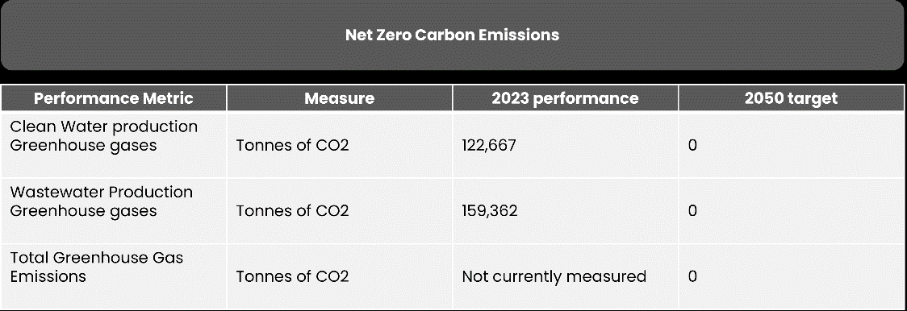

Instruction text:

Page break: Yes

Title: Q30  
Question type: Essay

Implementation QID: Q30

Filter / routing information: No

Other potential instructions: No

|  |  |  |  |
| --- | --- | --- | --- |
| Answer options | Precodes | Fix | Screen |
| I don’t know | 1 | Fix |  |

|  |
| --- |
| **Looking after our natural environment** |

1. Question text: Here are the measures & targets relating to the outcome ‘Looking after our natural environment’.

Click the image to enlarge or click here to open the image in a new window.

Based on what you have read, how supportive are you of the targets Yorkshire Water has set for this outcome overall?

Instruction text: Please select one

Page break: Yes

Title: Q31  
Question type: Single Select

Randomisation: None

Implementation QID: Q31

Filter / routing information: No

Other potential instructions: No

|  |  |  |  |  |
| --- | --- | --- | --- | --- |
| Answer options | Precodes | Fix | Open | Screen |
| Very supportive | 1 |  |  |  |
| Fairly supportive | 2 |  |  |  |
| Neutral | 3 |  |  |  |
| Fairly unsupportive | 4 |  |  |  |
| Very unsupportive | 5 |  |  |  |
| I’m not sure | 6 |  |  |  |

1. Question text: Are there any targets you feel are not going far enough?

Click the image to enlarge or click here to open the image in a new window.

Instruction text: Please select all that apply

Page break: Yes

Title: Q32  
Question type: Multi Select

Randomisation: None

Implementation QID: Q32

Filter / routing information: No

Other potential instructions: No

|  |  |  |  |  |  |
| --- | --- | --- | --- | --- | --- |
| Answer options | Precodes | Fix | Excl. | Open | Screen |
| Eliminate serious pollution incidents | 1 |  |  |  |  |
| Eliminate pollution incidents | 2 |  |  |  |  |
| Reduce sewage discharges from Storm Overflow to rivers and the coast | 3 |  |  |  |  |
| Reduce phosphorous in wastewater discharges to rivers | 4 |  |  |  |  |
| Bathing water quality – beaches and rivers | 5 |  |  |  |  |
| Increasing biodiversity | 6 |  |  |  |  |
| Biodiversity net gain | 7 |  |  |  |  |
| Blue-green storm overflow solutions | 8 |  |  |  |  |
| None, I think all the targets are acceptable | 99 |  |  |  |  |
| Unsure/ I don’t know | 100 |  |  |  |  |

1. Question text: You mentioned some targets were not going far enough, please tell us why and what you might expect them to be?

Click the image to enlarge or click here to open the image in a new window.

Instruction text:

Page break: Yes

Title: Q33  
Question type: Essay

Implementation QID: Q33

Filter / routing information: IF Q32≠ CODE 99 OR CODE 100

Other potential instructions: No

|  |  |  |  |
| --- | --- | --- | --- |
| Answer options | Precodes | Fix | Screen |
| I don’t know | 1 | Fix |  |

|  |
| --- |
| **SECTION 5: BILL IMPACT** |

**Info Text:** Thank you for your input so far! We’ve got a few final questions on billing and overall feedback on the strategy.

Page break: Yes

Title: Info3

Question type: Info

Implementation QID: Info3

Filter / routing information: No

Other potential instructions: No

1. Question text: As mentioned earlier, Yorkshire Water have a legal obligation to deliver huge programmes of work up to 2050, this has been mandated by the Government and its environmental agencies. Below you will see a summary of each 5-year period, showing the work that will be carried out and the average bill increase during each 5-year period (compared to the current bill average).

For example, across the 5-year billing period 2025-2030, the average bill payer will pay £537 per year, from 2030-2035 the average bill payer will pay £644 on average etc. For context, the current average bill in 2023/24 is £426, in 2024/25 it will be £429.

Inflation is not included in the below figures. This is likely to also impact bills.

Click the image to enlarge or click here to open the image in a new window.

Based on what you have read, how strongly do you agree with the following…

Instruction text: Please click on the buttons to rate the question.

Page break: Yes

Title: Q34  
Question type: Rating Scale

Randomisation: Randomised

Implementation QID: Q34

Filter / routing information: No

Other potential instructions: No

|  |  |  |  |
| --- | --- | --- | --- |
| Answer options | Precodes | Fix | Open |
| The forecasted bills are affordable for me | 1 |  |  |
| The forecasted bills are good value for money considering the work that’s being undertaken | 2 |  |  |
| I understand why the cost of bills will increase | 3 |  |  |

|  |  |  |
| --- | --- | --- |
| Scale options | Precodes | Fix |
| Strongly agree | 1 |  |
| Somewhat agree | 2 |  |
| Neither agree nor disagree | 3 |  |
| Somewhat disagree | 4 |  |
| Strongly disagree | 5 |  |

1. Question text: Is there anything missing from the list of activities that you would expect to be carried out by Yorkshire Water during this time?

Click the image to enlarge or click here to open the image in a new window.

*Please note: any additional activities would increase the impact on the average bill further.*

Instruction text:

Page break: Yes

Title: Q35  
Question type: Essay

Implementation QID: Q35

Filter / routing information: No

Other potential instructions: No

|  |  |  |  |
| --- | --- | --- | --- |
| Answer options | Precodes | Fix | Screen |
| No, I don’t think anything is missing | 1 | Fix |  |

1. Question text: Given the cost-of-living challenges faced by customers, Yorkshire Water would like to understand which bill option would be the most manageable for customers. Over the 25-year period there are 3 options, they are as follows:

Option 1: spread the cost evenly over each 5-year period. For example, this represents a step up in bills from 2025 but the bill remains the same beyond this up to 2030. This pattern then repeats again for each 5-year period (blue “average” line/row in illustration below).

Option 2: spread the cost to reflect the money that Yorkshire Water are spending on improvements during that time – for example, this will be a slightly smaller step up in bills in 2025 and a slight increase across the 5-year period up to 2030. This pattern then repeats again for each 5-year period (yellow “natural” line/row in illustration below)

Option 3: Start with a much smaller increase to your water bill from 2025 and then have a rising bill which increases year on year up to 2030. This pattern then repeats again for each 5-year period (green “rising” line/row in illustration below).

Please note that the below bill values are indicative at the moment, these are still being worked on by Yorkshire Water. The graph and the table are showing the same information. For context, the current average bill in 2023/24 is £426, in 2024/25 it will be £429.

Please also be aware that inflation is something that also needs to be considered, this will have an impact on customers’ bills, and is out of Yorkshire Waters control.

Click on the image to enlarge or click here to open in a new window.

Which of these options would you prefer, where rank 1 is the option you’d most prefer and rank 3 is the option you’d least prefer.

Instruction text: Click or drag each item into a rank position.

Page break: Yes

Title: Q36  
Question type: Rank Sort

Randomisation: None

Implementation QID: Q36

Filter / routing information: No

Other potential instructions: No

|  |  |  |
| --- | --- | --- |
| Answer options | Precodes | Fix |
| Option 1 – a step up in bills in the first year, but it remains consistent for the rest of the 5-year period (average) this trend repeats every 5 years | 1 |  |
| Option 2 – the bill increases to reflect the costs that Yorkshire Water will incur during this time, a step up in bills in the first year, but a more gradual incline in bills over the remainder of the 5-year period (natural), this trend repeats every 5 years | 2 |  |
| Option 3 – A small increase to your water bill in the first year with a rising yearly bill for the rest of the 5-year period (rising), this trend repeats every 5 years | 3 |  |

|  |  |  |
| --- | --- | --- |
| Scale options | Precodes | Fix |
| 1 | 1 |  |
| 2 | 2 |  |
| 3 | 3 |  |

|  |
| --- |
| **SECTION 6: ADAPTIVE PLANNING** |

**Info Text:** We’re almost at the end of the survey now – just two questions to go!

Page break: Yes

Title: EndInfo

Question type: Info

Implementation QID: ID here

Filter / routing information: No

Other potential instructions: No

1. Question text: There is lots of planning involved in the Long-Term Delivery Strategy (LTDS) and Yorkshire Water will pause at various intervals to see if the plan is delivering what it needs to. There are some key triggers that might cause Yorkshire Water to review their delivery strategy, such as:

-Climate change: if the impact of climate change is felt more quickly than expected, or alternatively lower than expected

-Technology: the water industry has various technological initiatives planned to modernise infrastructure (e.g. smart meters, smart water supply network). Length of implementation of these initiatives may trigger Yorkshire Water to review their strategy.

-Abstraction reductions: abstraction is the process of removing water from a river or water source. This can harm the environment if too much is removed so water companies are required by the government to limit abstractions. However the extent to which we will need to reduce abstractions in the future depends on climate change, policy regulations etc.

-Household demand for water: higher demand for water from customers would place a great strain on the network, lower demand would result in less strain – both scenarios could trigger a review.

Below you will see a graph that illustrates when a trigger point could happen to lead Yorkshire Water to re-plan:

Are there any other factors that you think could arise in the future that could trigger Yorkshire Water to review their Long Term Delivery Strategy?

Instruction text:

Page break: Yes

Title: Q37  
Question type: Essay

Implementation QID: Q37

Filter / routing information: No

Other potential instructions: No

|  |  |  |  |
| --- | --- | --- | --- |
| Answer options | Precodes | Fix | Screen |
| I can’t think of any other factors/ No idea | 1 | Fix |  |

|  |
| --- |
| **SECTION 7: OVERALL** |

1. Question text: Based on everything you have read today about Yorkshire Water’s Long Term Delivery Strategy, to what extent do you agree with the following…

Instruction text: Please click on the buttons to rate the question.

Page break: Yes

Title: Q38  
Question type: Rating Scale

Randomisation: Randomised

Implementation QID: Q38

Filter / routing information: No

Other potential instructions: No

|  |  |  |  |
| --- | --- | --- | --- |
| Answer options | Precodes | Fix | Open |
| I am supportive of the strategy overall | 1 |  |  |
| The strategy makes me feel positively towards Yorkshire Water | 2 |  |  |
| The strategy is clear and comprehensive | 3 |  |  |
| I trust Yorkshire Water to delivery this strategy | 4 |  |  |

|  |  |  |
| --- | --- | --- |
| Scale options | Precodes | Fix |
| Strongly agree | 1 |  |
| Somewhat agree | 2 |  |
| Neither agree nor disagree | 3 |  |
| Somewhat disagree | 4 |  |
| Strongly disagree | 5 |  |

1. Question text: Thanks for all of your answers so far! Just one final question, please could you tell us, what is your post code?

*This will only be looked at on an aggregate level for analysis purposes. If you prefer not to share this information, please just type NA in the box below.*

Instruction text:

Page break: Yes

Title: Q39_qcode  
Question type: Essay

Implementation QID: ID here

Filter / routing information: No

Other potential instructions: No

|  |
| --- |
|  |

**Info Text:** Thanks for taking part, that’s all we had to ask you today.

Please be aware Yorkshire Water offer support to customer who struggle to afford their water bill. Please contact Yorkshire Water to discuss this. We also offer free additional services to customers in vulnerable circumstances, you can read about this on the website or contact Yorkshire Water to discuss how we can help you.

0800 1 38 78 78 or <https://www.yorkshirewater.com/bill-account/help-paying-your-bill/>

Please click continue to close the survey and submit your answers.

Page break: Yes

Title: ClosingThanks

Question type: Info

Implementation QID: ID here

Filter / routing information: No

Other potential instructions: No