3607

YORKSHIRE WATER A&AT Quant Script

|  |
| --- |
| **PROJECT MANAGER:** **Click here for guidance on what to put in this section**  **Pls tick methodology, and where applicable nominate “back checking questions” (AKA “BCQs”). These must include the demographic questions.**  **Online only**  **CATI only (DP: add QAX)**  **CAPI/Tablet (If yes PM Nominate 3*Backchecking Questions: )QAZ2 Paper showcard? Y N**  **CATI recruit for online/field (PM pls. Nominate BCQs: )QAZ3**  **Field recruit for online/CATI (PM pls. Nominate BCQs: )QAZ1**  **Recruit only (ie for qual)** |



Affordability and Acceptability Testing

Thank you very much for agreeing to complete this on-line survey which is being conducted by Accent, an independent research agency. This survey is designed to help Yorkshire Water, your water and wastewater service provider, to understand your views on how affordable and acceptable their future plans are. The closing date for completion of this survey is 3rd of September 2023.

**NOT PANEL:** Anyone completing the survey will be eligible for a £10 voucher (either an Amazon voucher, an M&S voucher or a One4All voucher). Alternatively, we can donate your incentive to WaterAid. Details on how to claim your voucher are given at the end of the survey.

We will just ask you a couple of questions to check that you are eligible to take part in this research.

Any answer you give will be treated in confidence in accordance with the Code of Conduct of Market Research Society. If you would like to confirm Accent’s credentials type Accent in the search box at: <https://www.mrs.org.uk/researchbuyersguide>.

You do not have to answer any question you do not wish to and you may terminate the interview at any point.

**IF MOBILE DEVICE SHOW:** **This survey is best undertaken on a tablet or a PC. If you do use a smartphone you can switch between desktop mode and mobile mode at any time by clicking the button at the bottom of the screen.**

## Scoping questions

Any data collected over the course of this interview that could be used to identify you, such as your name, address, or other contact details, will be held securely and will not be shared with any third party unless you give permission (or unless we are legally required to do so). Our privacy statement is available at <https://www.accent-mr.com/privacy-policy/>.

Please do not include names, addresses, or other personal data in your responses to any questions, unless asked to do so.  
  
Do you agree to proceeding with the interview on this basis?

Yes

No **THANK AND CLOSE**

**IF HH:** Do you or any of your close family work in market research or for a water company?

Yes **THANK & CLOSE**

No

**IF HH:** How old are you?

**OPEN TEXT RESPONSE BOX**

Prefer not to say **THANK AND CLOSE**

Under 18 **THANK AND CLOSE**

**PN: PLEASE RECODE IN THE FOLLOWING AGE BANDS**

18-24

25-34

35-44

45-54

55-64

65-74

75+

**IF HH:** Are you the person in your household who is responsible, either solely or jointly, for paying for your water services bill?

Yes

No, I am not responsible for paying the bill **THANK AND CLOSE**

Don’t know **THANK AND CLOSE**

Are you currently charged for water through a water meter?

Yes

No

Don’t know

**IF HH:** Yorkshire Water is your water and sewerage supplier. Does this sound right?

Yes **GO TO MAIN QUESTIONNAIRE**

No **THANK AND CLOSE**

Don’t know **GO TO MAIN QUESTIONNAIRE**

**IF NHH:** Are you solely or jointly responsible as the decision maker for your organisation’s water and sewerage service at any of its premises?

Yes

No **THANK AND CLOSE**

**IF NHH**: Is Yorkshire Water responsible for the water and sewerage services at your organisation?

Yes

No **THANK AND CLOSE**

Don’t know **THANK AND CLOSE**

Q8A **IF NHH**: When answering this questionnaire, we would like you to think only about sites your organisation might have that are in the Yorkshire Water area. Is that OK?

Yes

No **THANK AND CLOSE**

## Main Questionnaire

Thank you, I can confirm you are in scope for the survey. The questionnaire will take about 15 minutes to complete.

For convenience you can stop and return to complete the questionnaire as many times as you wish, although once submitted you will not be able to enter again.

## Affordability

We are now going to ask you some questions about your **[IF HH]** household’s**[IF NHH]** organisation’s financial situation.

Thinking about your finances over the last year, how often, if at all, **[IF HH]** have you struggled to pay at least one of your household bills? **[IF NHH]** Has your organisation struggled to pay at least one of its bills? **SINGLECODE, RANDOMISE WITH REVERSE ORDER EXCEPT FOR PREFER NOT TO SAY**

All of the time

Most of the time

Sometimes

Rarely

Never

Prefer not to say

Overall, how well would you say **[IF HH]** you are/**[IF NHH]** your organisation is managing financially now? **SINGLECODE, RANDOMISE WITH REVERSE ORDER EXCEPT FOR PREFER NOT TO SAY**

**[IF HH]** Living/**[IF NHH]** Operating comfortably

Doing alright

Just about getting by

Finding it quite difficult

Finding it very difficult

Prefer not to say

Thinking about your **[IF HH]** household’s/ **IF NHH]** your organisation’s financial situation over the next few years up to 2030, do you expect it to get: **SINGLECODE, RANDOMISE WITH REVERSE ORDER EXCEPT FOR PREFER NOT TO SAY**

*Please select one answer only*

A lot worse

A bit worse

Stay the same

A bit better

A lot better

Prefer not to say

Don't know

**IF NHH**: How much are you currently paying for your water and sewerage services bill, **each year**?

[Open-ended answer] **DP PLEASE ADD TEXT BOX**

Don’t know

How easy or difficult is it for **[IF HH]** you **[IF NHH]** your company/organisation to afford to pay your current water and sewerage bill: **SINGLECODE, RANDOMISE WITH REVERSE ORDER EXCEPT FOR PREFER NOT TO SAY**

*Please select one answer only*

Very easy

Fairly easy

Neither easy nor difficult

Fairly difficult

Very difficult

Don’t know

Q13A **IF NHH**: At this point I need you to look at an individualised graph, mapping out what future water bills may look like for your organisation under the plans Yorkshire Water have.

Please could you go to LINK TBC

You should see a thank you note, then on the next page somewhere to put your annual water bill amount into. Please enter the bill for all sites your company operates in the Yorkshire Water area. An estimate is absolutely fine.

Interviewer note, do not proceed until they have gone to the website and put in their bill amount. Only then can you proceed. You must not proceed without them seeing these materials.

Looking at web page

Cannot proceed now **Open appointment box**

## Proposed changes to your water/sewerage bill for the years 2025-2030

The next set of questions are about proposed changes to your water & sewerage bill for the years 2025-2030. The chart below shows these changes. It also shows how inflation may impact on your bill, based on the Bank of England's inflation forecasts.

*Water bills change each year in line with inflation.*

*Inflation is the increase in prices paid for goods and services over time. Household incomes also change over time.*

*• If your household income keeps up with inflation (ie. increases at the same rate), then you are likely to notice little difference in what you are paying for things.*

*• If inflation increases by a faster rate than your household income, then you are likely to have less money to go around.*

*• If your household income increases by a faster rate than inflation, then you are likely to have more money to go around.*

*The Bank of England aims to keep inflation at 2%, but it has recently been much higher than this. As well as changing by inflation each year, bills change by an amount set by Ofwat (the water regulator) as part of their price review process every five years.*

*The proposed bills you will see from 2025 to 2030 include the Bank of England forecasts for inflation from 2025 to 2030, and proposed amounts to cover the investment in water and sewerage services needed over the next few years.*

The following chart shows the expected increase in your water/sewerage bill over the next few years.

The blue part of each column is what the underlying change to your bills would look like if there were no inflation. The orange part is what inflation will add on top. So your actual bill would be the two parts added together.

**The figure above each bar represents the total expected bill amount (the blue plus the orange)**

@DP please use

\\accent-mr.com\accentdata\Projects\3607 Yorkshire Water A&AT\Project management\workings & analysis\Yorkshire Water AAT Bill Increase Graph calculator QUANT COGS.xlsx

For the main social tariff customers will need to see the second graph but for the cogs that is not necessary.

@DP, YW DO want totals over the bars please.

**(Placeholder – this graph will be tailored according to bill amounts, and total added)**

**IF Social Tariff Customer (from sample):** This bill profile is based on the financial support scheme you are currently on. Yorkshire Water are still working on the Social Tariff bill, so this could potentially change.

**IF NHH DK @Q12**: Please note this bill profile is based on a stand in figure.

How easy or difficult do you think it would be for **[IF HH]** you **[IF NHH]** your company/organisation to afford these water/sewerage bills? **SINGLECODE, RANDOMISE WITH REVERSE ORDER EXCEPT FOR DON’T KNOW**

Very easy

Fairly easy

Neither easy nor difficult **HH ONLY GO TO Q15**

Fairly difficult **HH ONLY GO TO Q15**

Very difficult **HH ONLY GO TO Q15**

Don’t know

**[IF HH ONLY] IF Q14= 3,4,5** Which of the following do you think you would need to do to pay for the increase in your water bills between 2025 and 2030 **MULTICODE, RANDOMISE WITH REVERSE ORDER EXCEPT FOR DON’T KNOW**

Shopping around more

Spending less on food shopping and essentials

Spending less on non-essentials

Cutting back on non-essential journeys in my vehicle

Eat out less

Using less fuel such as gas or electricity in my home

Using less water

Using my savings

Using credit more than usual, for example, credit cards, loans or overdrafts

Ask family and friends for financial support

Other, please specify [OPEN RESPONSE] **DP PLEASE ADD TEXT BOX**

Other, please specify [OPEN RESPONSE] **DP PLEASE ADD TEXT BOX**

Don’t know

## Acceptability

We are now going to ask you some questions about your views on your water company's business plan. Water companies are required to put together business plans for each five year period. The plan we are showing you is for 2025- 2030.

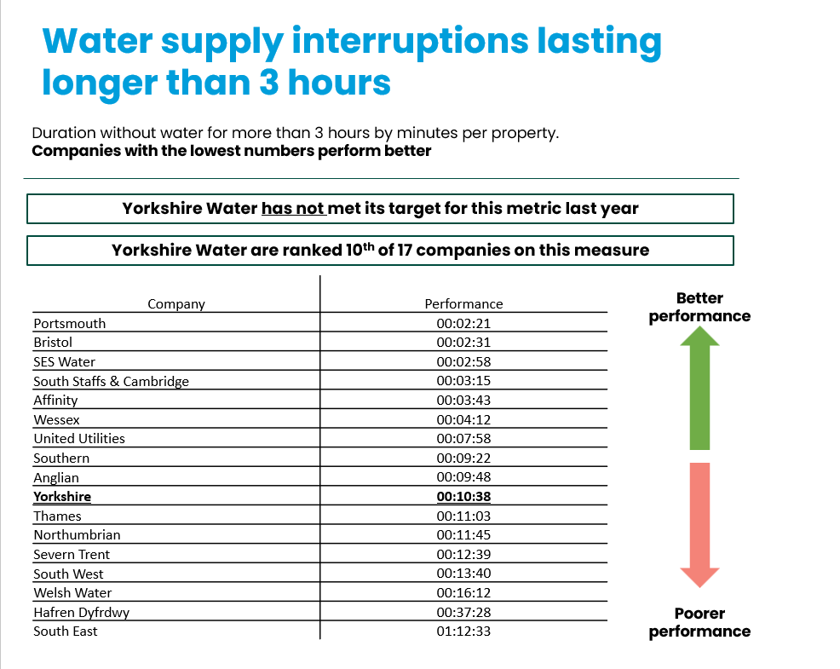The following chart shows how Yorkshire Water are performing in the area of Water supply interruptions longer than 3 hours, against both their target and also the other water companies.

The following slide shows what Yorkshire Water is proposing doing to improve things:

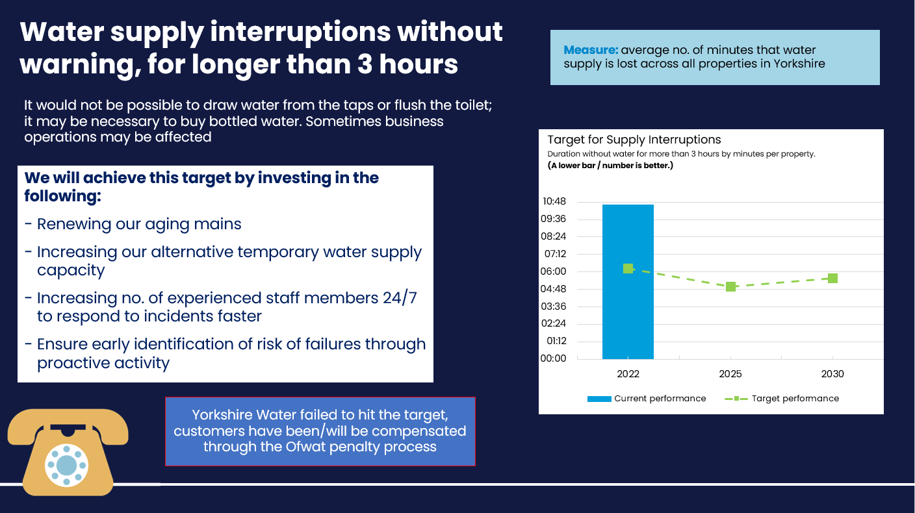

The following chart shows how Yorkshire Water are performing in the area of Water quality contacts, against both their target and also the other water companies.

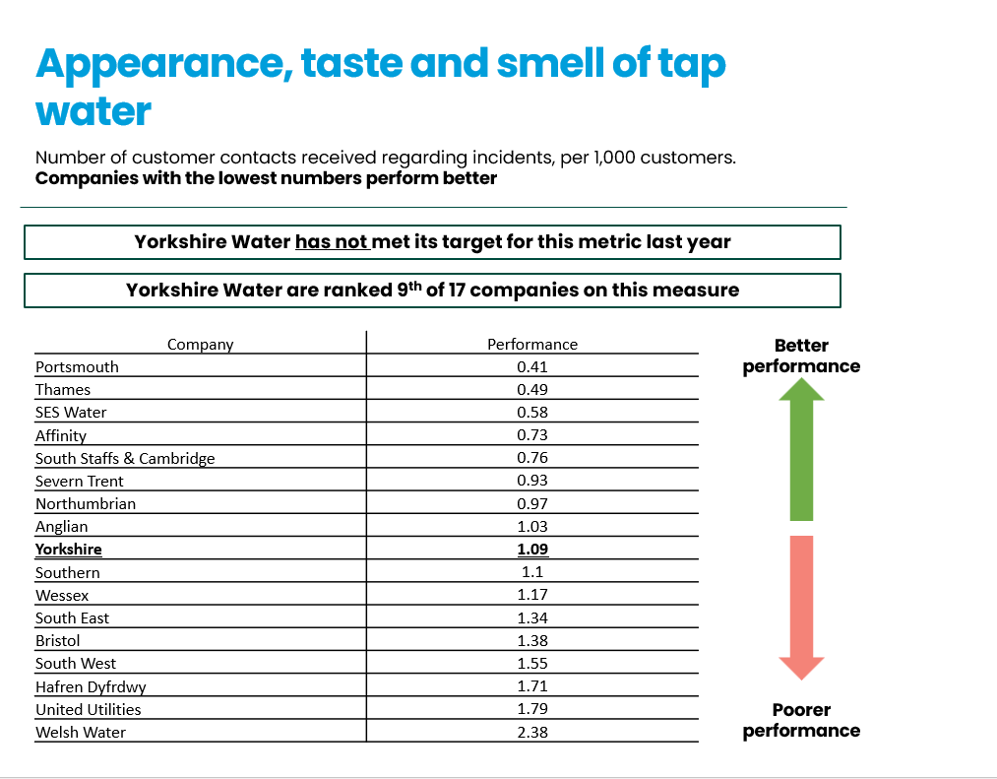

The following chart shows what Yorkshire Water is proposing doing to improve things:

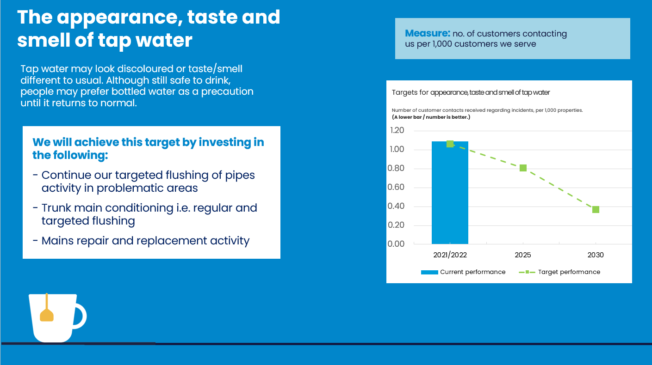

The following chart shows how Yorkshire Water are performing in the area of reducing leaks, against both their target and also the other water companies.

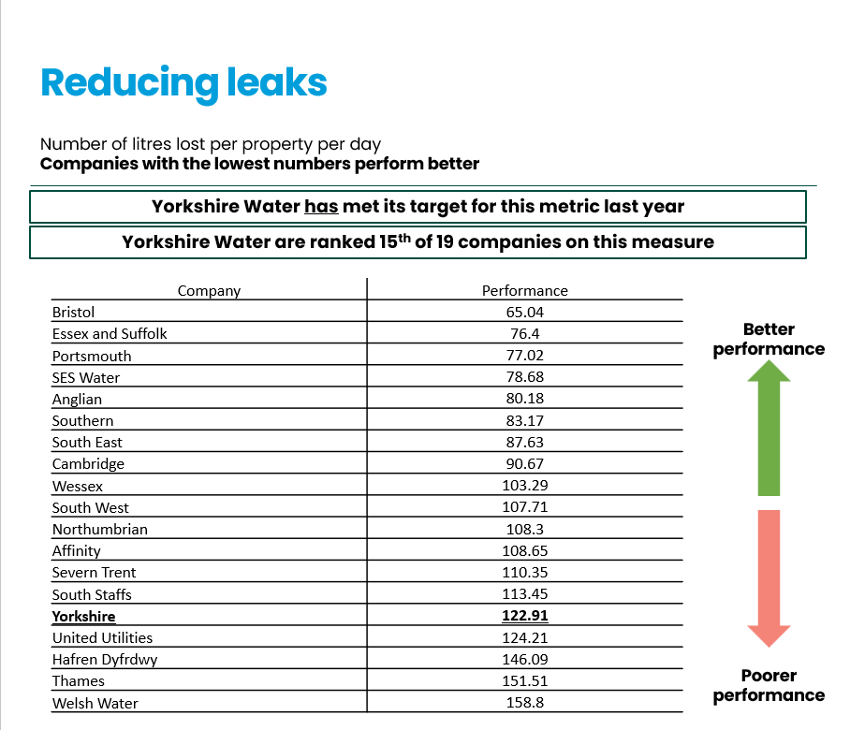

The following chart shows what Yorkshire Water is proposing doing to improve things:

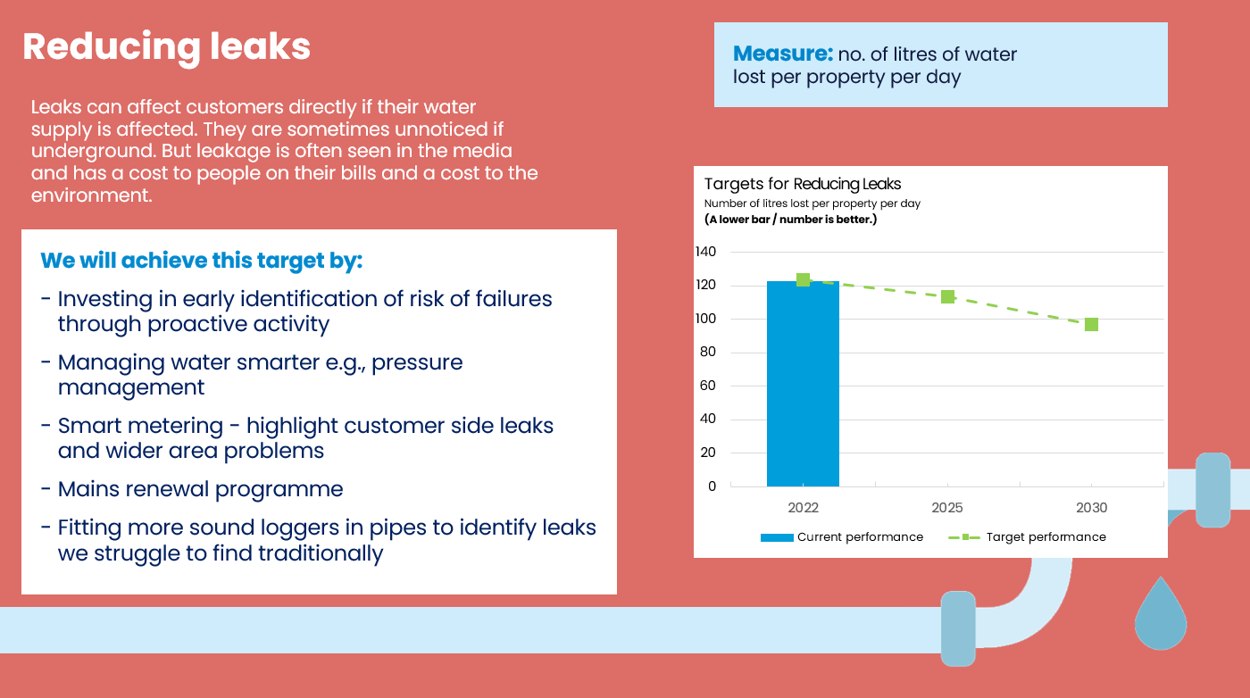

Based on what you have just read, which of these three parts of the business plan is the most important to you? **SINGLECODE, RANDOMISE WITH REVERSE ORDER EXCEPT FOR DON’T KNOW**

*Please select one answer only*

Reducing the duration of water interruptions of longer than 3 hours

Preventing issues with taste/smell/appearance of tap water

Reducing leakage

Don't know/can't say

The following chart shows how Yorkshire Water are performing in the area of sewage flooding inside of properties, against both their target and also the other water companies.

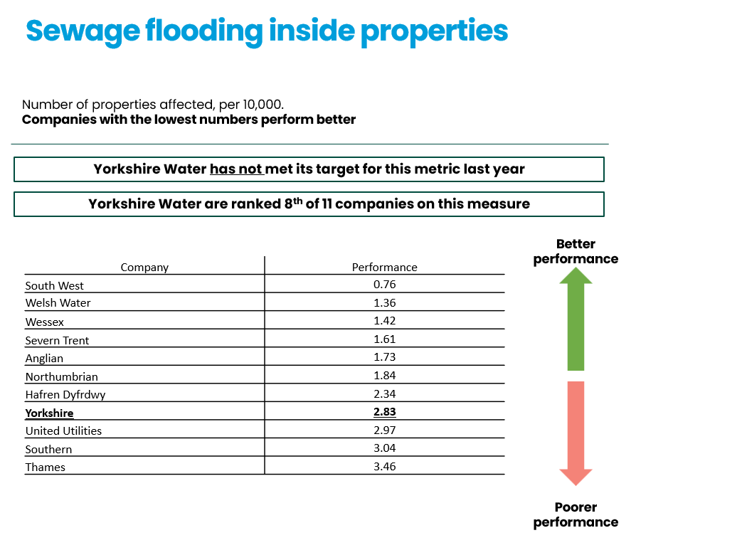

The following chart shows what Yorkshire Water is proposing doing to improve things:

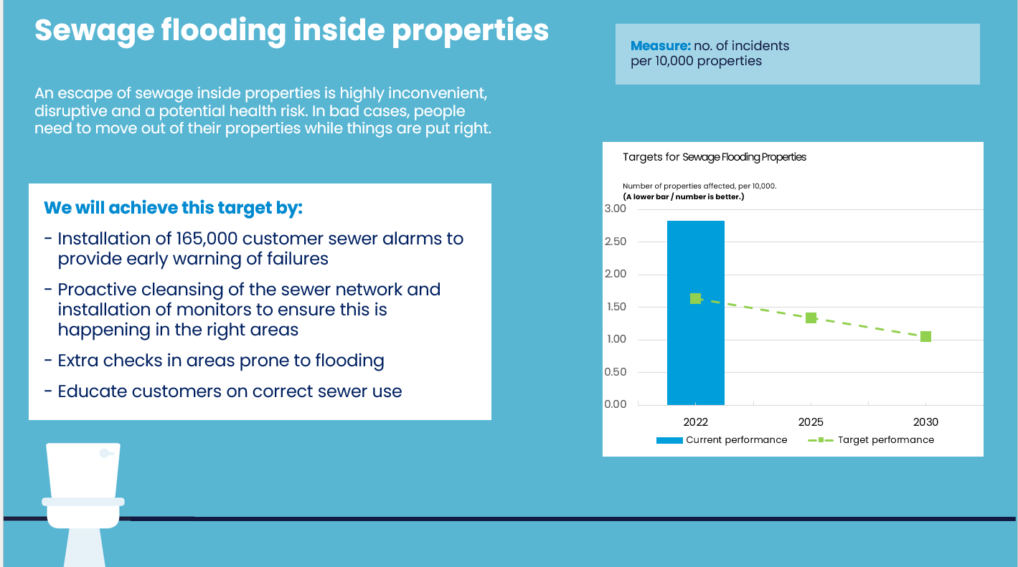

The following chart shows how Yorkshire Water are performing in the area of sewage flooding of gardens and outbuildings, against both their target and also the other water companies.

The following slide shows what Yorkshire Water is proposing doing to improve things:

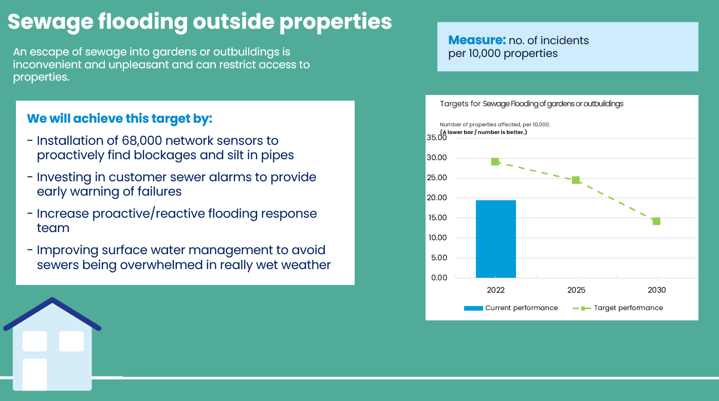

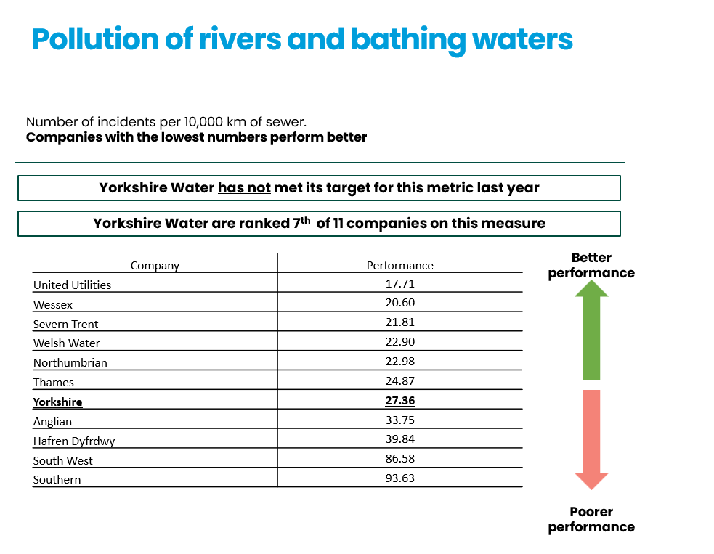The following chart shows how Yorkshire Water are performing in the area of pollution incidents, against both their target and also the other water companies.

The following chart shows what Yorkshire Water is proposing doing to improve things:

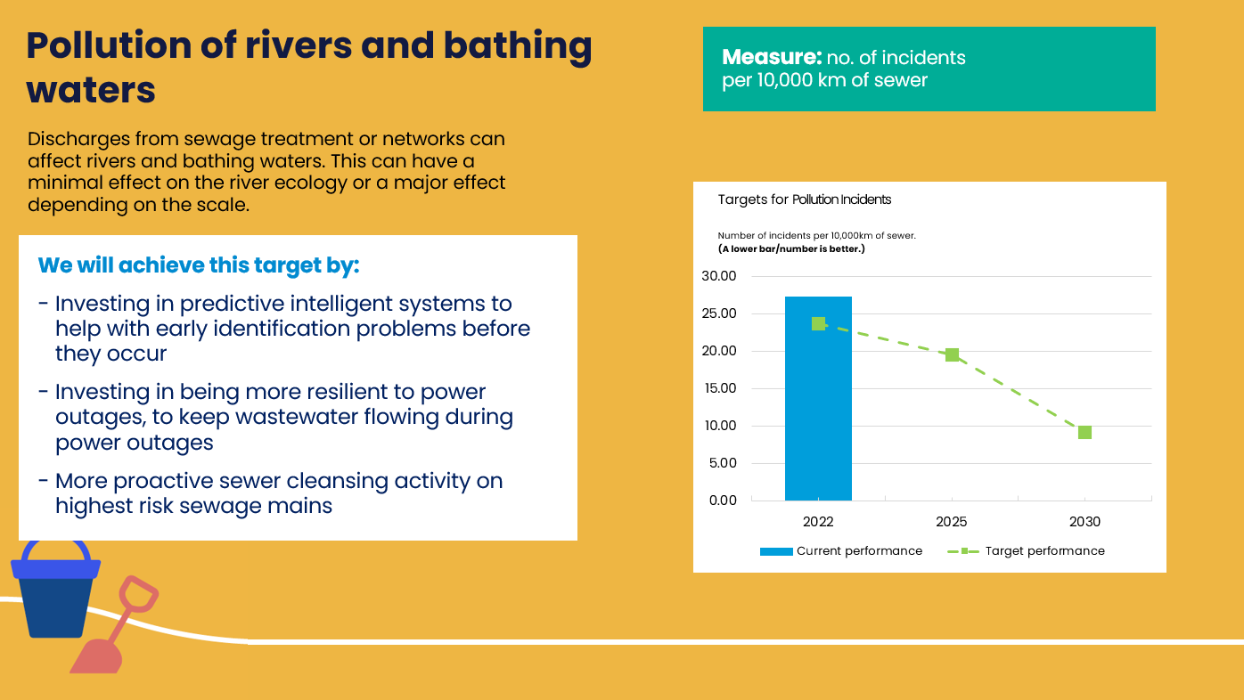

Based on what you have just read, which of these three parts of the business plan is the most important to you? **SINGLECODE, RANDOMISE WITH REVERSE ORDER EXCEPT FOR DON’T KNOW**

*Please select one answer only*

Sewage flooding **inside** of properties

Sewage Flooding **outside** of properties

Pollution Incidents

Don't know/can't say

1. The following slide describes one of the additional components of Yorkshire Water’s business plan; Enhancement 1

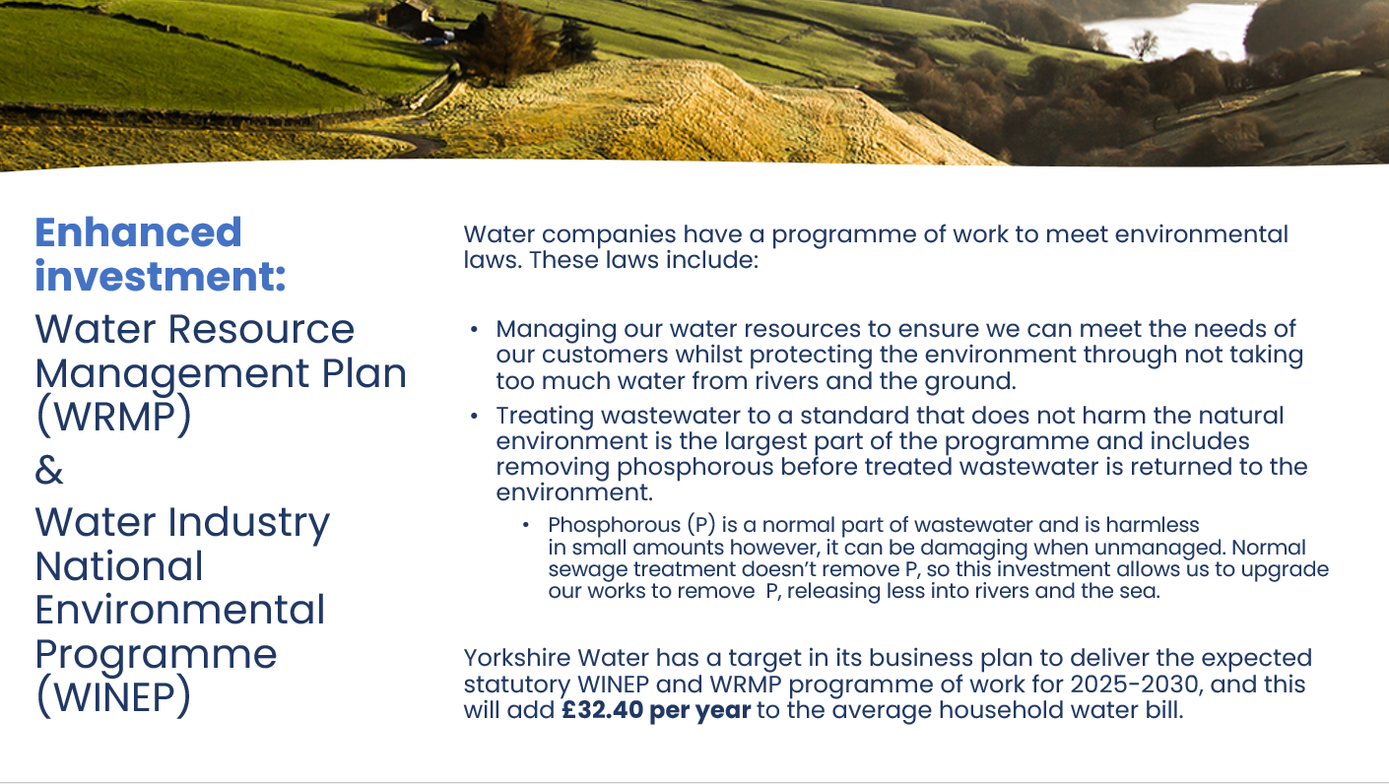

The following slide describes one of the additional components of Yorkshire Water’s business plan; Enhancement 2

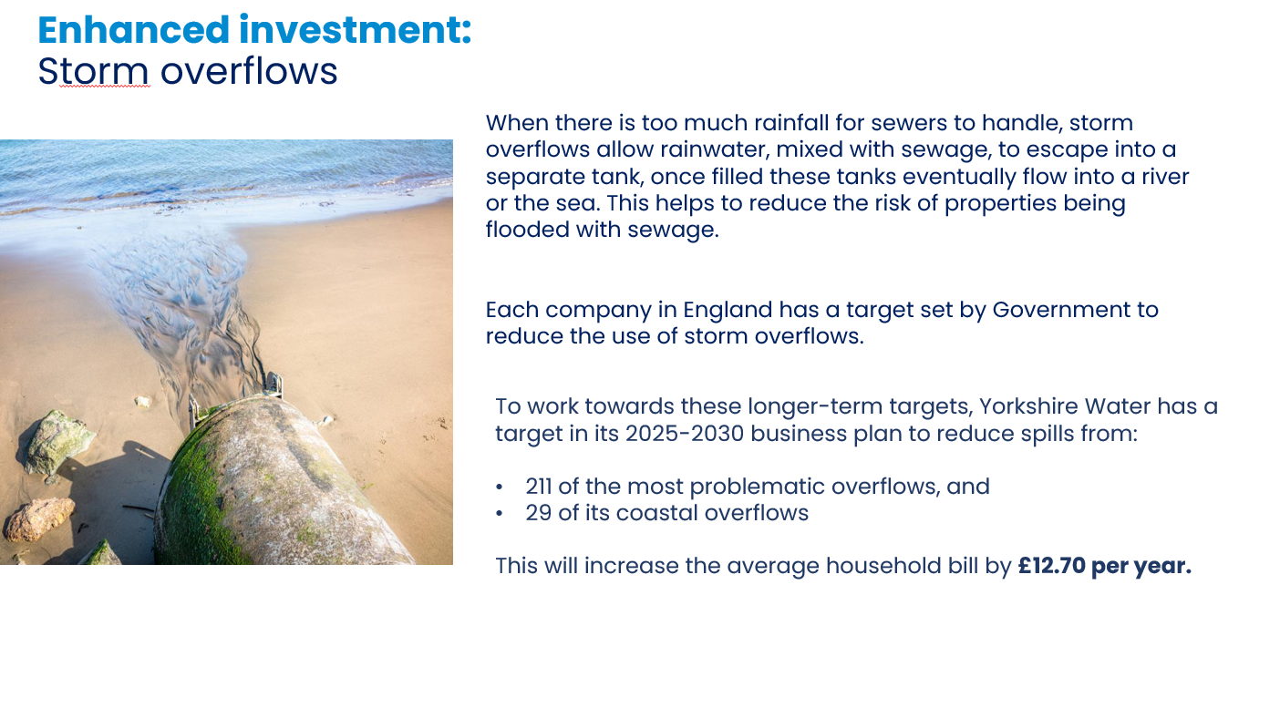

The following slide describes one of the additional components of Yorkshire Water’s business plan; Enhancement 3

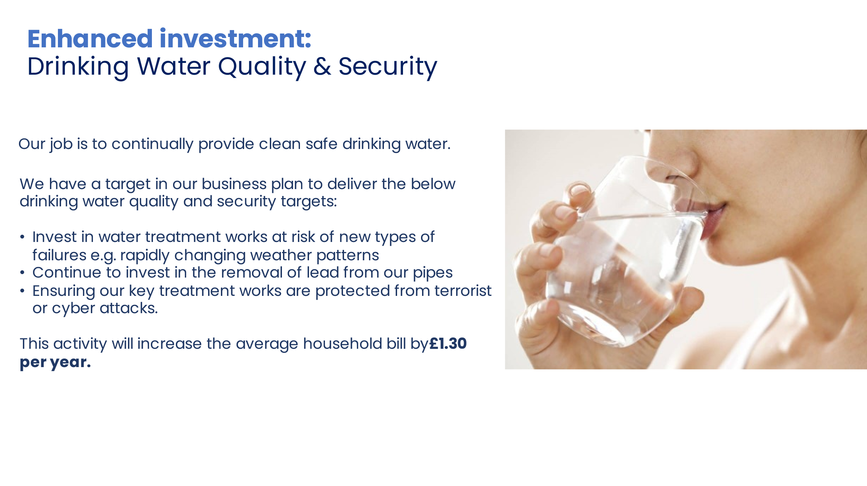

Based on what you have just read, which of these three parts of the business plan is the most important to you? **SINGLECODE, RANDOMISE WITH REVERSE ORDER EXCEPT FOR DON’T KNOW**

*Please select one answer only*

Water Resource Management Plan (WRMP) & Water Industry National Environmental Programme (WINEP)

Storm overflows

Drinking Water Quality & Security

Don't know/can't say

1. The following slide describes one of the additional components of Yorkshire Water’s business plan; Enhancement 4:

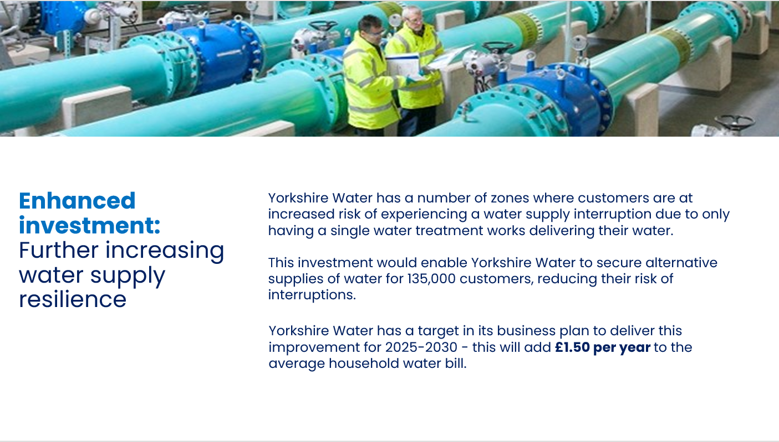

The following slide describes one of the additional components of Yorkshire Water’s business plan; Enhancement 5

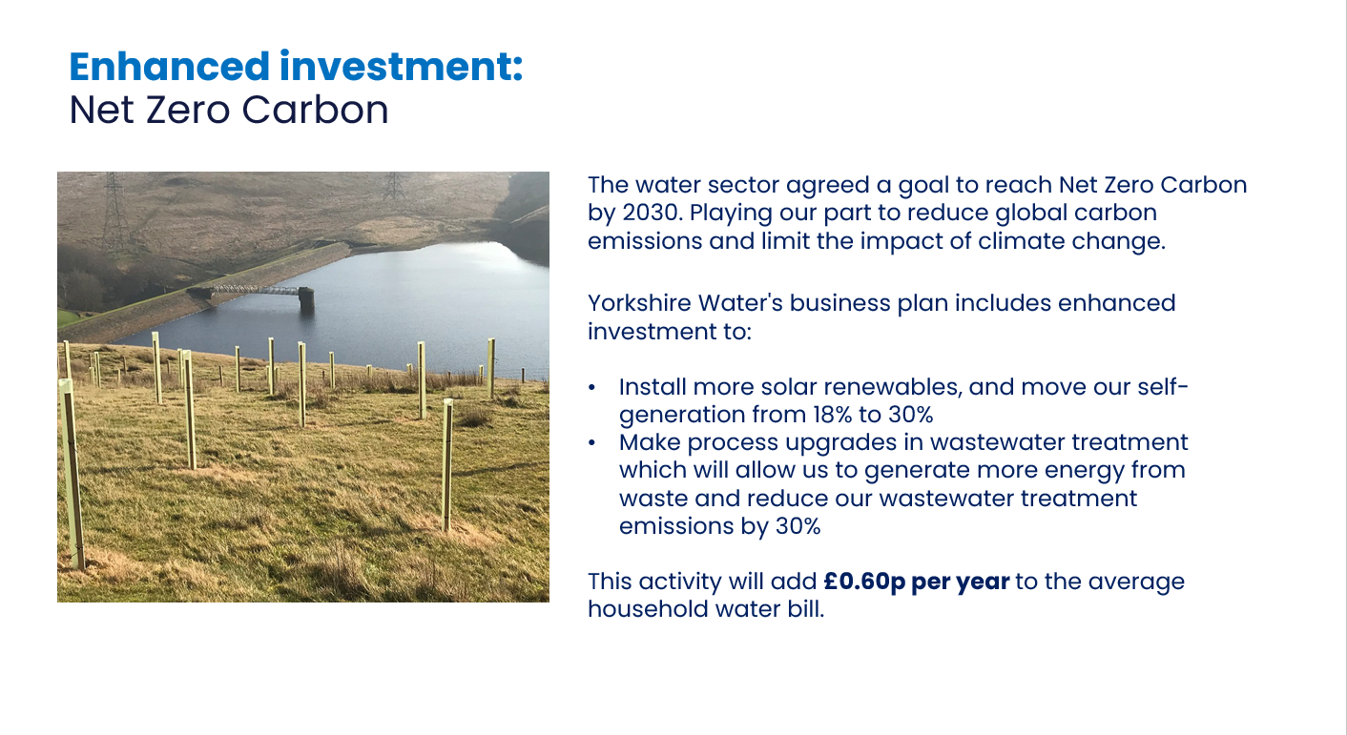

The following slide describes one of the additional components of Yorkshire Water’s business plan; Enhancement 6

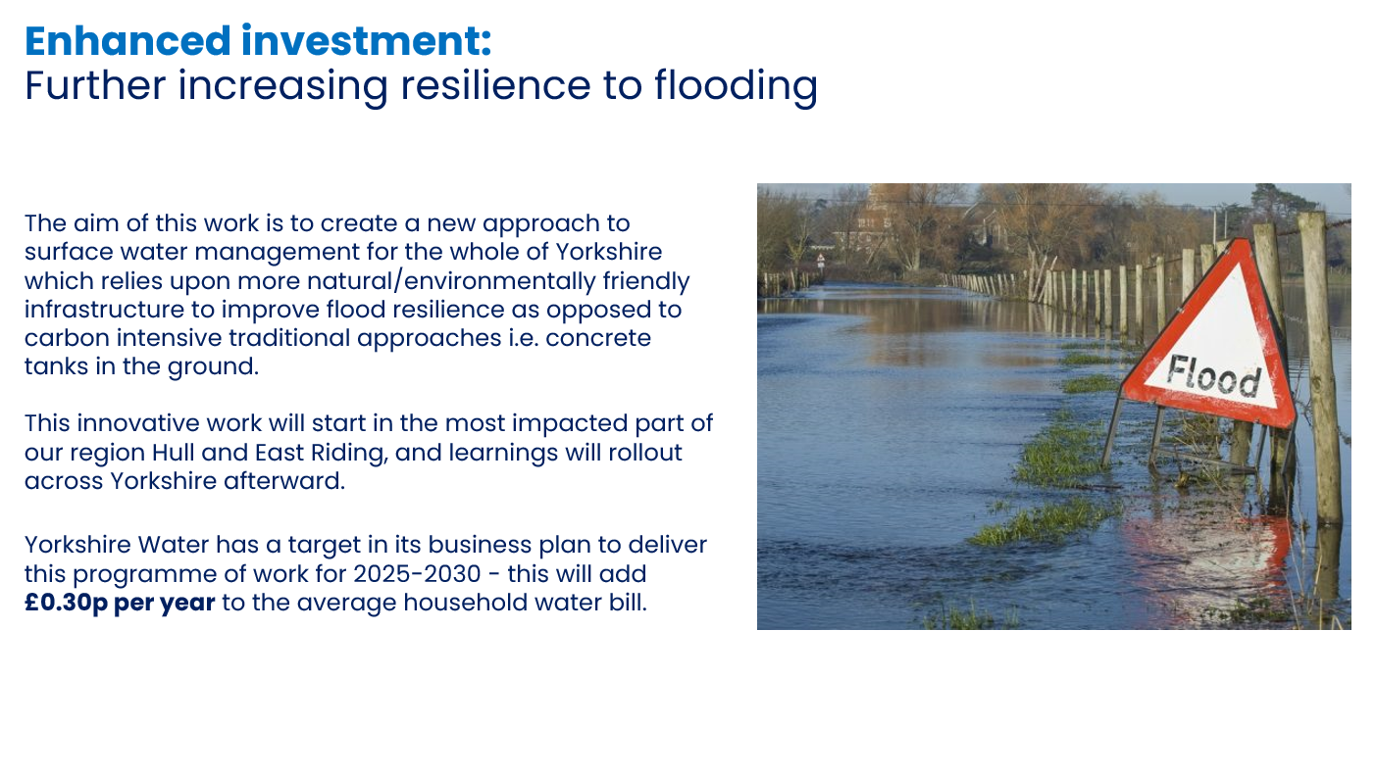

Based on what you have just read, which of these three parts of the business plan is the most important to you? **SINGLECODE, RANDOMISE WITH REVERSE ORDER EXCEPT FOR DON’T KNOW**

*Please select one answer only*

Further increasing water supply resilience

Net Zero Carbon

Further increasing resilience to flooding

Don't know/can't say

Based on everything you have seen and read about Yorkshire Water’s proposed business plan, how acceptable or unacceptable is it to you? **SINGLECODE, RANDOMISE WITH REVERSE ORDER EXCEPT FOR DON’T KNOW**

*Please select one answer only*

Completely acceptable **GO TO Q34**

Acceptable **GO TO Q34**

Unacceptable **GO TO Q33**

Completely unacceptable **GO TO Q33**

Don't know/can't say

**IF Q32=3 or 4** What are the two main reasons that you feel the proposals for your water services are unacceptable? **MAXIMUM 2 ANSWERS, RANDOMISE**

*Please choose up to two answers only*

The bill increases are too expensive

Company profits are too high

Companies should pay for service improvements

I expect better service improvements

The plan is poor value for money

Compared to energy prices it is more expensive

I am dissatisfied with current services

The plans don’t focus on the right services

I won’t be able to afford this

I don’t trust them to make these service improvements

Other 1, please specify [OPEN RESPONSE] **DP PLEASE ADD TEXT BOX**

Other 2, please specify [OPEN RESPONSE] **DP PLEASE ADD TEXT BOX**

Don’t know/ can’t say

**IF 32=1 OR 2** What are the two main reasons that you feel the proposals for your water supply are acceptable? **MAXIMUM 2 ANSWERS, RANDOMISE**

*Please choose up to two answers only*

The plan is good value for money

The plan is affordable

Compared to energy prices it’s cheaper

Their plans seem to focus on the right services

The company provides a good service now

I support what they are trying to do in the long term

The change to my bill is small

I trust them to do what’s best for customers

I have been dissatisfied with the service recently but am pleased that they are making improvements

Other 1, please specify [OPEN RESPONSE] **DP PLEASE ADD TEXT BOX**

Other 2, please specify [OPEN RESPONSE] **DP PLEASE ADD TEXT BOX**

Don’t know/ can’t say

Long term investment by Yorkshire Water will require an increase in customer bills. Bills could increase in different ways over time. For example, there could be increases now for current bill payers, or bigger increases in the long term for future generations. Which one of the following options would you prefer? **SINGLECODE**

*Please select one answer only*

An increase in bills starting sooner, spreading increases across different generations of bill-payers

An increase in bills starting later, putting more of the increases onto younger and future bill-payers

I don’t know enough at the moment to give an answer

**ALL SKIP**

## **HH ONLY:** Household Demographic

Thank you. Now just a few questions to check that we are speaking to people of all types.

In which of the following ways do you identify?

Female

Male

I identify in another way

Prefer not to say

Which ONE of the following best describes the occupation of the main income earner in your household? If you or the main income earner are self-employed please tick the option that most relates to the type of work you/they do for the company(s) you/they work for.

**High** **managerial, administrative or professional** e.g. doctor, lawyer, medium / large company director (50+ people)

**Intermediate managerial, administrative or professional** e.g. teacher, manager, accountant

**Supervisor, administrative or professional** e.g. police officer, nurse, secretary, self-employed

**Skilled manual worker** e.g. mechanic, plumber, electrician, lorry driver, train driver

**Semi-skilled or unskilled manual worker** e.g. waiter, factory worker, receptionist, labourer

Housewife/Househusband

Unemployed

Retired **GO TO Q39**

Student

Prefer not to say

**IF Q38=RETIRED ASK** Does the main income earner have a state pension, a private pension or both?

State only

Private only

Both

Prefer not to say

1. **IF Q39= PRIVATE OR BOTH ASK:** How would you describe the main income earner’s occupation type before retirement?

**High managerial, administrative or professional** e.g. doctor, lawyer, medium / large company director (50+ people)

**Intermediate managerial, administrative or professional** e.g. teacher, manager, accountant

**Supervisor, administrative or professional** e.g. police officer, nurse, secretary, self-employed

**Skilled manual worker** e.g. mechanic, plumber, electrician, lorry driver, train driver

**Semi-skilled or unskilled manual worker** e.g. waiter, factory worker, receptionist, labourer

Housewife/Househusband

Unemployed

Student

None of these

Prefer not to say

Which of the following apply to you? We would like to collect this to ensure that a variety of particular needs are represented in the study, but you do not need to answer if you do not wish to. This information will not be shared with any third party and will be destroyed within 12 months of project completion. **MULTICODE**

*Please select all that apply*

I or another member of my household is disabled or suffer(s) from a debilitating illness **CODED AS MEDICAL VULNERABILITY**

I or another member of my household have/has a learning difficulty **CODED AS MEDICAL VULNERABILITY**

I or another member of my household relies on water for medical reasons **CODED AS MEDICAL VULNERABILITY**

I or another member of my household is visually impaired (ie struggles to read even with glasses) **CODED AS COMMUNICATIONS VULNERABILITY**

I or another member of my household am/is over the age of 75 years old **CODED AS LIFE STAGE VULNERABILITY**

I or another member of my household speaks English as a second language **CODED AS COMMUNICATIONS VULNERABILITY**

I or another member of my household is deaf or hard of hearing **CODED AS COMMUNICATIONS VULNERABILITY**

I or another member of my household is a new parent **CODED AS LIFE STAGE VULNERABILITY**

None of these apply to me

Prefer not to say

What is your ethnic group? Choose one option that best describes your ethnic group or background **SINGLECODE**

*Please select one answer only*

**WHITE**

English, Welsh, Scottish, Northern Irish or British

Irish

Gypsy or Irish Traveller

Any other White background

**Mixed**

White and Black Caribbean

White and Black African

White and Asian

Any other Mixed background

**Asian or Asian British**

Indian

Pakistani

Bangladeshi

Chinese

Any other Asian background

**Black or Black British**

Caribbean

African

Any other Black background

**Other Ethnic Group**

Arab

Any other ethnic group

Prefer not to say

Which of the following bands does your household income fall into from all sources before tax and other deductions? **SINGLECODE**

Up to £199 a week/Up to £10,399 a year

From £200 to £299 a week/From £10,400 to £15,599 a year

From £300 to £499 a week/From £15,600 to £25,999 a year

From £500 to £699 a week/From £26,000 to £36,399 a year

From £700 to £999 a week/From £36,400 to £51,999 a year

From £1,000 to £1,399 a week/From £52,000 to £72,799 a year

From £1,400 to £1,999 a week/From £72,800 to £103,999 a year

£2,000 and above a week/£104,000 and above a Year

Don’t know

Prefer not to say

**GO TO Q32**

## **NHH only:** Demographic Questions

How does your organisation mainly use water at its premises? **MULTICODE**

*Please select all that apply*

For the manufacturing process which is essential to the running of your organisation (eg to power machinery, agricultural production etc)

For the supply of services your organisation provides (eg cleaning services etc)

For an ingredient or part of the product or service your organisation provides (eg food or drink, chemical, cosmetics manufacturer etc)

For normal domestic use for your organisation’s customers and employees (eg customer toilets, supply of drinking water)

None of the above

Don’t Know

How many sites in the UK does your organisation operate from?

1

2

3

4

5-10

11-50

51-250

250

Prefer not to say

How many employees does your organisation have in the UK?

0 (sole trader)

1 to 9 employees (micro)

10 to 49 employees (small)

50 to 249 employees (medium)

250+ employees (large)

Prefer not to say

Which of the following best defines the core activity of your organisation?

Agriculture, forestry and fishing

Mining and quarrying

Energy or water service & supply

Manufacturing

Construction

Wholesale and retail trade (including motor vehicles repair)

Transport and storage

Hotels & catering

IT and Communication

Finance and insurance activities

Real estate activities

Professional, scientific and technical activities

Administrative and Support Service Activities

Public administration and defence

Education

Human health and social work activities

Arts, entertainment and recreation

Other service activities

Other (please specify)

Prefer not to say

## Classification Questions

**IF NON PANEL:** We mentioned that there would be a £10 incentive for completing this survey. This incentive will be administered by Accent, within 4 weeks.   
  
This can be sent as an Amazon, Marks & Spencer or One4All voucher by email. Alternatively, we can donate your incentive to WaterAid. Which would you prefer?

Amazon voucher by email COLLECT email address

M&S Voucher by email COLLECT email address

One4All by email COLLECT email address

Donation to Water Aid

If you have any queries about your incentive, please contact us on 0131 220 8770.

1. Thank you. Would you be willing to be contacted again if we need to clarify any of the answers you have given today?

Yes

No

Thank you. This research was conducted under the terms of the MRS code of conduct and is completely confidential.

**CATI ONLY** Interviewer Confirmation

I confirm that this interview was conducted under the terms of the MRS code of conduct and is completely confidential

Yes

No

**QEND [IF HH]** Yorkshire Water offers help to qualifying low-income households that are struggling to afford their water and wastewater bills. More information about this can be found here: <https://www.yorkshirewater.com/bill-account/help-paying-your-bill/>

SYSTEM INFORMATION

Time interview completed:

|  |
| --- |
| **Grid style for mobiles:** [**click here for example**](https://secure2.accent-mr.com/C10/accisformat7.ASPX?urn=opensurvey)  GM 1 to force mobiles to show grid (for small grids)  GAR 1 to show vertical text for answer headings  GAR 2 to show vertical text for answer headings on mobile devices only |

|  |
| --- |
| **Questionnaire Style (default is 7):** **Click here for details**  **Choose base format: Choose variations:**  Accis3 Question and answer fonts (full list: <https://fonts.google.com/>)  Accis4 Header font  Accis5 Tick box style (1-6)  Accis6 Next/previous button style (1-3)  Accis7 Font colour (use HEX code <http://html-color-codes.info/#HTML_Color_Picker>)  #  Accis8 **Other colours:** Note that CLR1 and CLR6 change a number of different elements (to easily keep the colours consistent)  CLR1 Progress bar border, progress colour, button colour  #  #  #  #  #  #  #  #  CLR2 Progress bar background colour  CLR3 Page background colour  CLR4 Header background colour (if different from CLR1)  CLR5 Header font colour  CLR6 Border colour for selected checkbox and checkbox border colour when hovered over (if different from CLR1)  CLR7 Background colour for selected checkbox (if different from CLR1)  CLR8 Tick/circle colour for selected checkbox |